

**Ho Chi Minh, 17/12/2020**

**Lecturer: Huynh Xuan Phung**

**Members: Nguyen Truong Hoang Hieu 17110030**

**Nguyen Tan Loc 17110048**

**TOPIC: BUILDING A WEBSITE FOR REMOTE DIAGNOSTICS**

**HO CHI MINH UNIVERSITY OF TECHNOLOGY AND EDUCATION**

**BỘ GIÁO DỤC VÀ ĐÀO TẠO  
TRƯỜNG ĐẠI HỌC KINH BẮC**

**SUBJECT: PROJECT 3**

**FINAL PROJECT**

**Score**

|  |  |  |  |
| --- | --- | --- | --- |
| Criteria | Content | Presentation | Overall |
| Score |  |  |  |

Observations of Instructor

Evaluation:

Nguyen Truong Hoang Hieu:   
Nguyen Tan Loc:

Teacher Guide

**Phung**

**Huynh Xuan Phung**

**Contents:**

Criteria 2

Content 2

Presentation 2

Overall 2

Score 2

List of figures: 5

List of tables: 6

Chapter 1: Program Overview 8

1.1 About the Websites 8

1.1.1 Purpose 8

1.1.2 Requirements 8

1.1.3 Project Analysis 8

1.1.4 Expected Interface 8

1.1.5 Technical Requirements 9

1.1.6 Technology and Tool 9

Chapter 2: Work Assignment 9

2.1. Work Plan 9

2.2 Work Assignment 10

Chapter 3: Design Software 10

3.1 Design Interface 11

3.1.1 Program Interface 11

3.2 Business Process 15

3.2.1 Process Description 15

3.3 Business Function Diagram 17

3.3.1 Identify Function 17

3.3.2 BDF 19

3.3.3 Non-functional requirement 19

3.4 Use case diagram 20

3.4.1 General use case diagram 20

3.4.2 Use case specification 20

3.5 Design Database 28

3.5.1 Database Diagram 29

3.5.2 Database Specification and Field Decsription 29

Chapter 4: Install and Test 35

Chapter 5: Conclusion 51

5.1 Conclusion 51

Reference 52

List of figures:

Figure 1: HomePage Interface 11

Figure 2: Login Interface 12

Figure 3: About Us Interface 12

Figure 4: Interface of user when log in successful (Home Page) 13

Figure 5: Page Patient Information 14

Figure 6: Page Admin Login 14

Figure 7: Interface of admin when log in successful (Admin Page) 15

Figure 8: Bussiness Diagram Function 19

Figure 9: General use case diagram 20

Figure 10: Database Diagram 29

Figure 11: Page for admin login 35

Figure 12: Dashboad of admin 36

Figure 13 Page add patient 37

Figure 14: Page show a list of patient 38

Figure 15: Page show detail information of patient 38

Figure 16: Add visit for patient 39

Figure 17: Save successful 39

Figure 18: Add medical for patient 40

Figure 19: Add successful 40

Figure 20: Add image, video, scan result 41

Figure 21: Page search patient 41

Figure 22 Page show list of medical supplies 42

Figure 23: Page show list of medical supplies 43

Figure 24: Page medical supplies 44

Figure 25: Page add new medical supplies 44

Figure 26: Page medical 45

Figure 27: Function add medical 45

Figure 28: Page faculty 46

Figure 29: Function add faculty 47

Figure 30: Page doctor information 47

Figure 31: Function add doctor 48

Figure 32: Save succsessful 49

Figure 33: Page account 49

Figure 34: Function add new account 50

Figure 35: Add successful 50

Figure 36: Embeded Video Call 51

# List of tables:

Table 1: Work Plan 9

Table 2: Work Assignment 10

Table 3: Process Description 15

Table 4: Login use case 20

Table 5: Add patient information 21

Table 6: Update patient information 22

Table 7: Delete patient information 23

Table 8: Add doctor information 24

Table 9: Update doctor information 25

Table 10: Delete doctor information 25

Table 11: Add medical supplies 26

Table 12: Update medical supplies 27

Table 13: Delete medical supplies 28

Table 14: Patient 29

Table 15: Prescription 30

Table 16: DetailPrescription 31

Table 17: Record 31

Table 18: DetailRecord 31

Table 19: Medicine 32

Table 20: Vat tu (Item) 32

Table 21: MedicalSupplies 33

Table 22: Category 33

Table 23: Faculty 33

Table 24: Doctor 33

Table 25: Account 34

Table 26: AttachmentAssigns 34

Table 27: Attachments 34

# 

# Chapter 1: Program Overview

## About the Websites

The traditional model of patient management still has some limitations, our state has been making great efforts to make patients more convenient and comfortable when entering the examination. However, some hospitals have overcome this problem, but not much with the current economic development situation of our country. The administrative procedures are quite complicated, a patient entering a hospital needs to follow a lot of procedures and paperwork which takes a lot of time.

### Purpose

* Help doctor can manage the patients, doctors, medicines….
* We can know the doctor of the patient
* We can know the detail of the patient
* We can know the detail of the medical supplies

### Requirements

* Manage patient’s information
* Doctors (Admin)
* Meidical supplies information and medicine information
* Report

### Project Analysis

* Building object – oriented software
* The output of data is the application

### Expected Interface

This project includes the following forms:

* Patients
* Doctors
* Medicine
* Meidical Supplies

### Technical Requirements

- Application of object-oriented programming

- Software capacity is light, stable running

### 1.1.6 Technology and Tool

- Design Graphical User Interface (GUI) by Visual Studio 2019 (Tool)

- Design View Model and Data Model by Visual Studio 2019 (Code C#)

- Building software on EntityFramework.6.2.0

- ASP.Net MVC

- HTML – CSS – Javascript – Bootstrap – Jquery

- SQL Server

# Chapter 2: Work Assignment

## 2.1. Work Plan

Table : Work Plan

|  |  |  |
| --- | --- | --- |
| **Week** | **Date** | **Work** |
| Week 1 | 13/10 | Design Home Page, About Us, Login and Register for User  Create My Profile for User, Login Page for Admin |
| Week 2 | 20/10 | Design Database and Design the Control page for Admin |
| Week 3 | 27/10 | Design Patient dashboard, new patient pages, all patient pages |
| Week 4 | 03/11 | Design Medicine dashboard, function to add new medical records, add prescription |
| Week 5 | 10/11 | Design Doctor can upload file medication instructions |
| Week 6 | 17/11 | Design Medical Supplies and function add, modify,delete of patient, doctor, medicine, medical supplies |
| Week 7 | 24/11 | Learn about video calls with WebRTC, OpentTok, FFMpeg |
| Week 8 | 1/12 | Use OpentTok but error because we don’t create Session and Token of RoomName in ASP.Net MVC |
| Week 9 | 8/12 | Use Embed Video Calls |
| Week 10 | 15/12 | Finish |

## 2.2 Work Assignment

Table : Work Assignment

|  |  |  |  |
| --- | --- | --- | --- |
| **Number Order** | **Name of student** | **Description** | **Contribute (%)** |
| 1 | Nguyen Tan Loc | Design Business Function Diagram and Database | 50% |
| 2 | Nguyen Truong Hoang Hieu | Design UI and connect with database | 50% |

# Chapter 3: Design Software

## 3.1 Design Interface

### Program Interface

Student name: Nguyen Truong Hoang Hieu

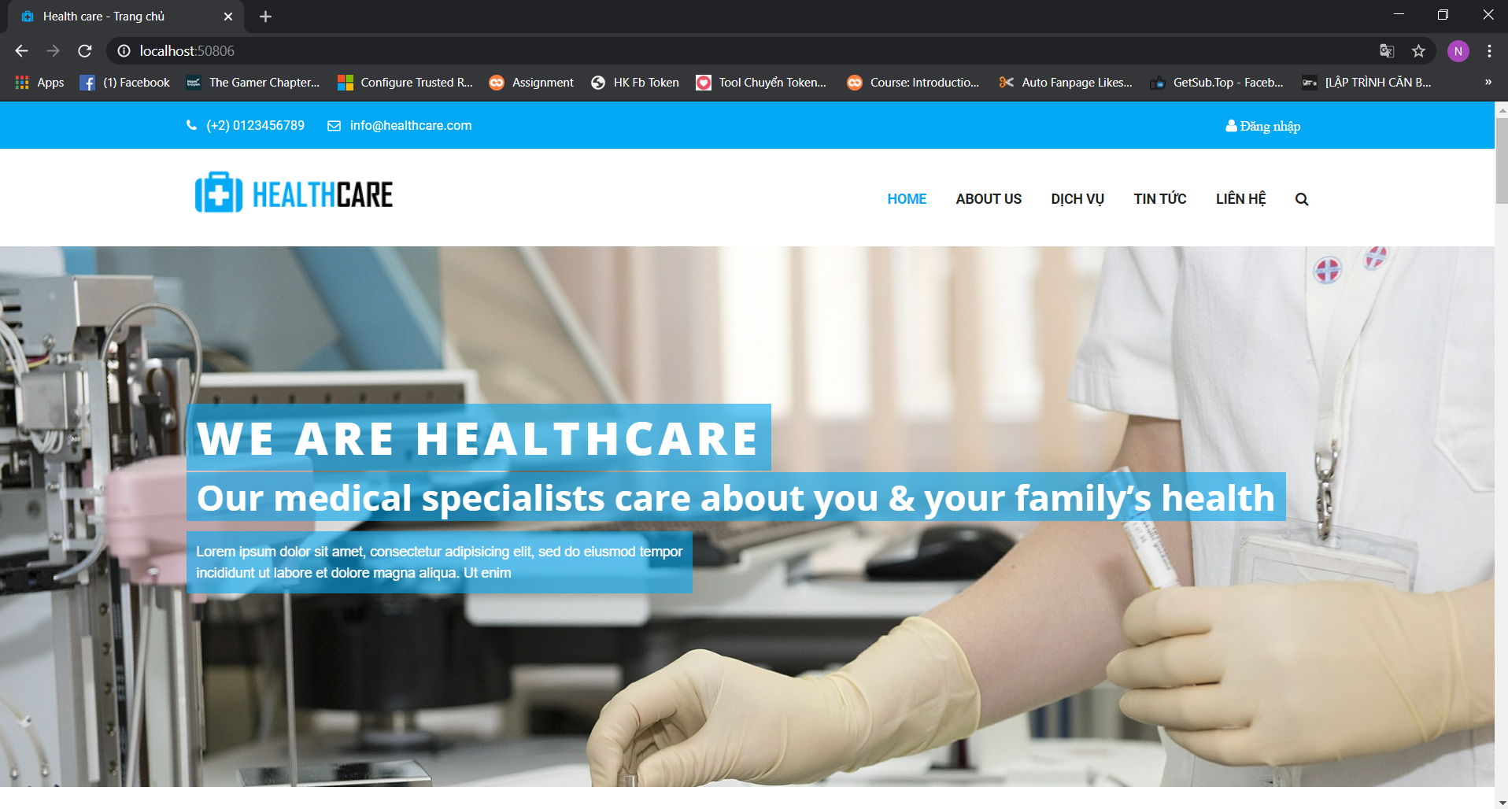

Figure : HomePage Interface

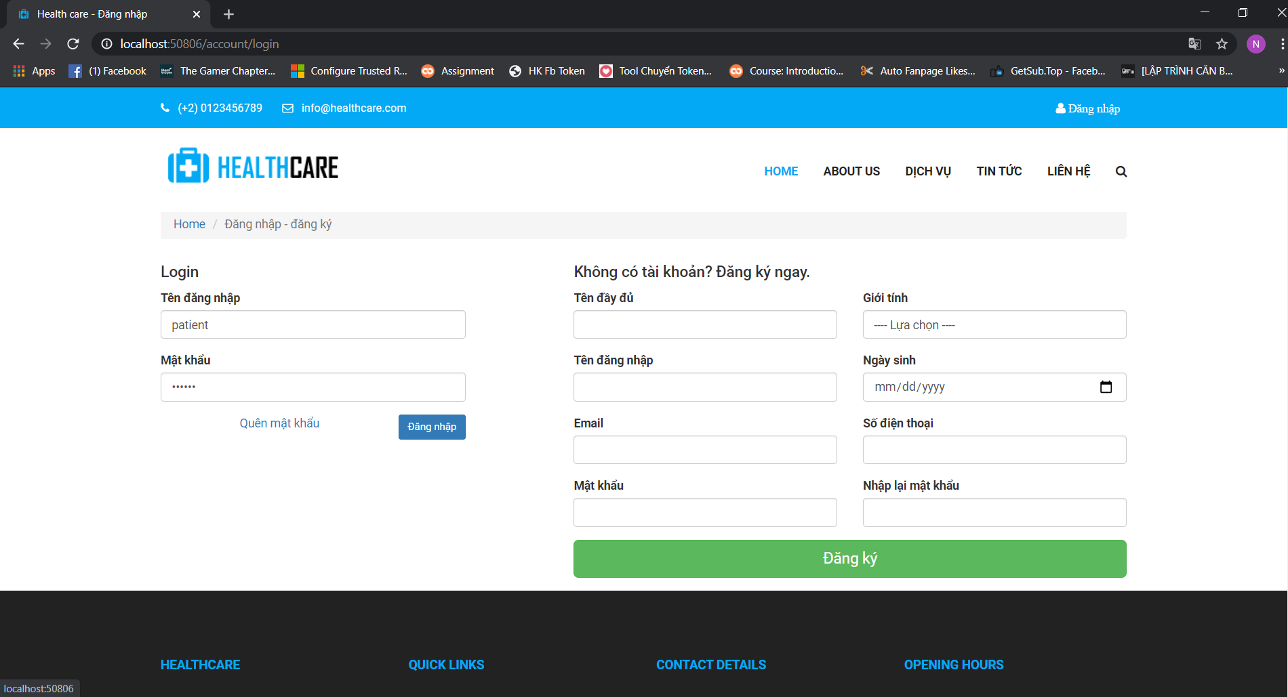

Figure : Login Interface

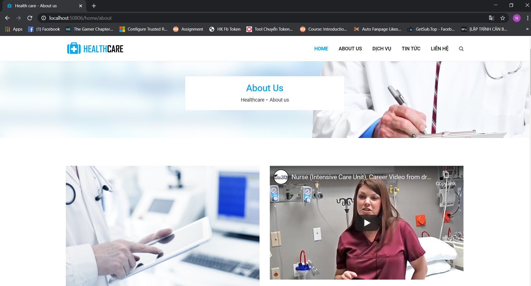

Figure : About Us Interface

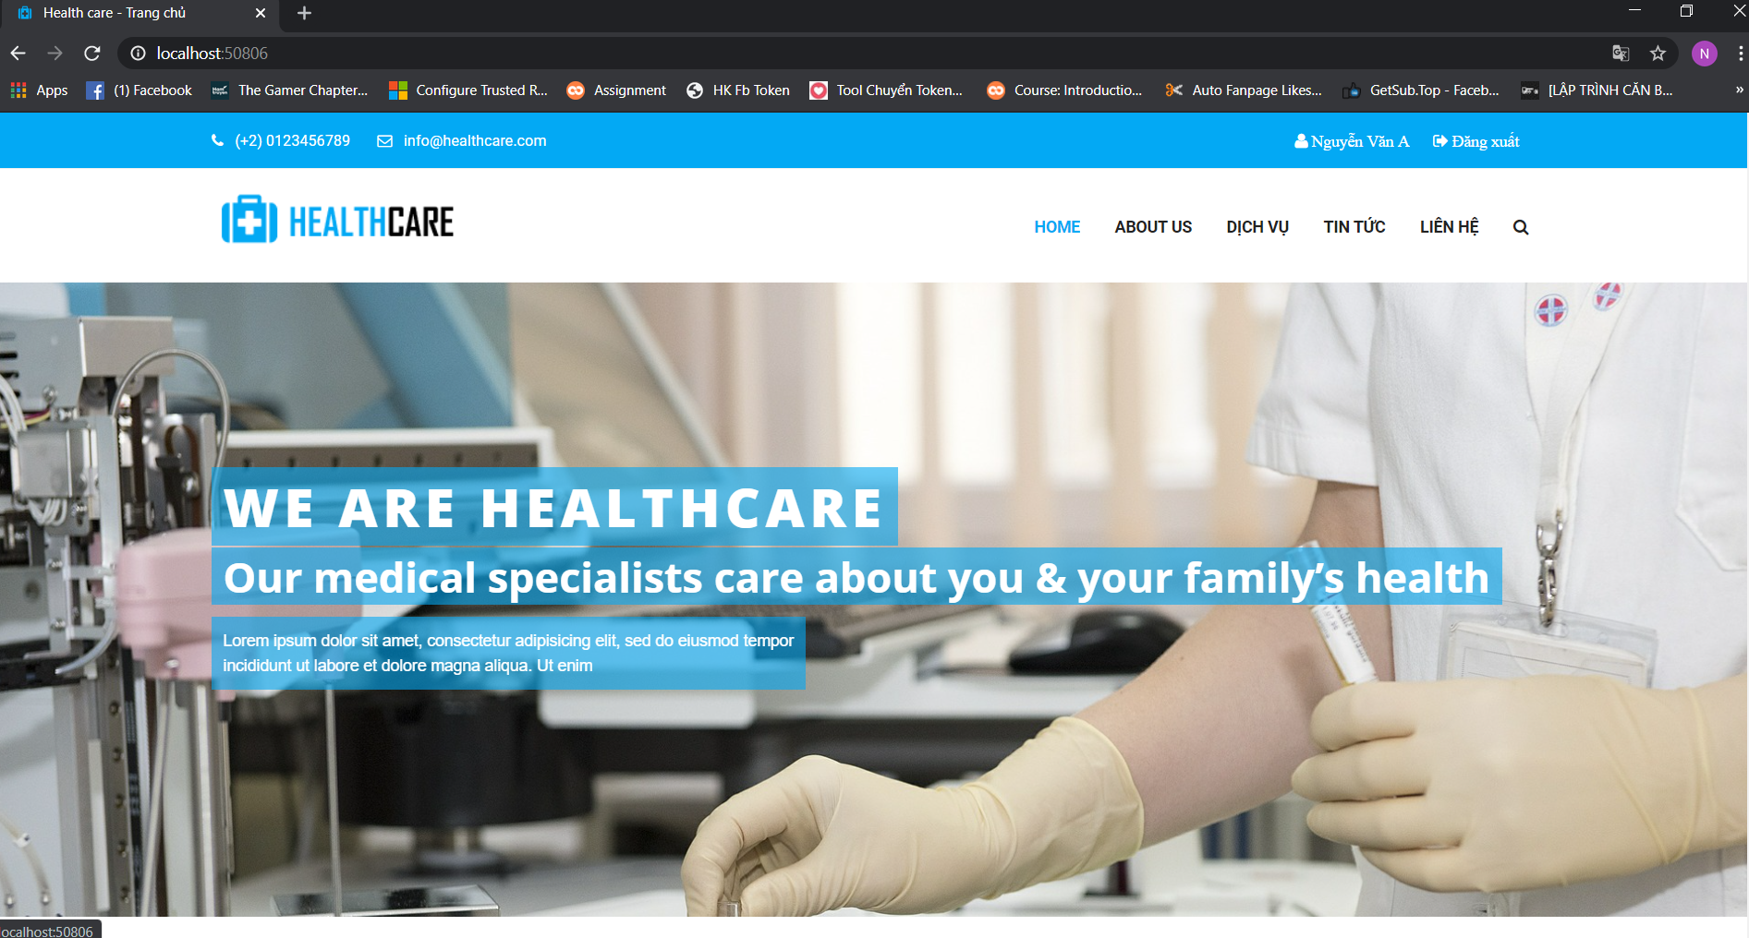

Figure : Interface of user when log in successful (Home Page)

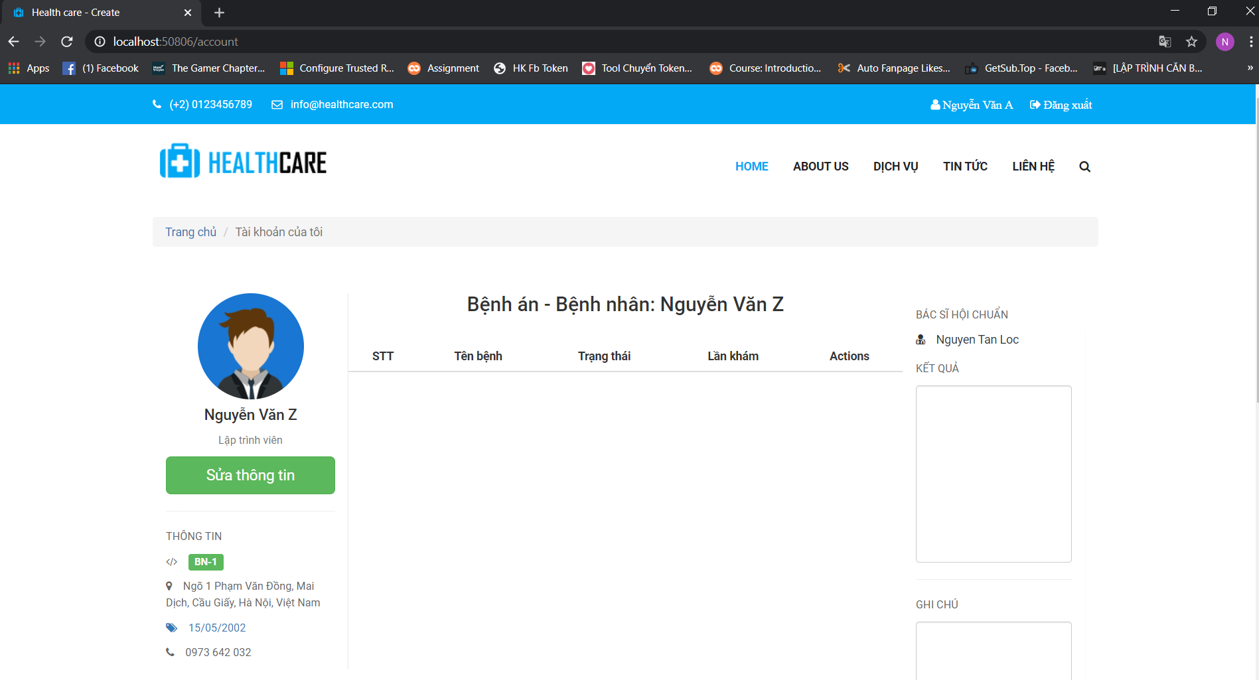

Figure : Page Patient Information

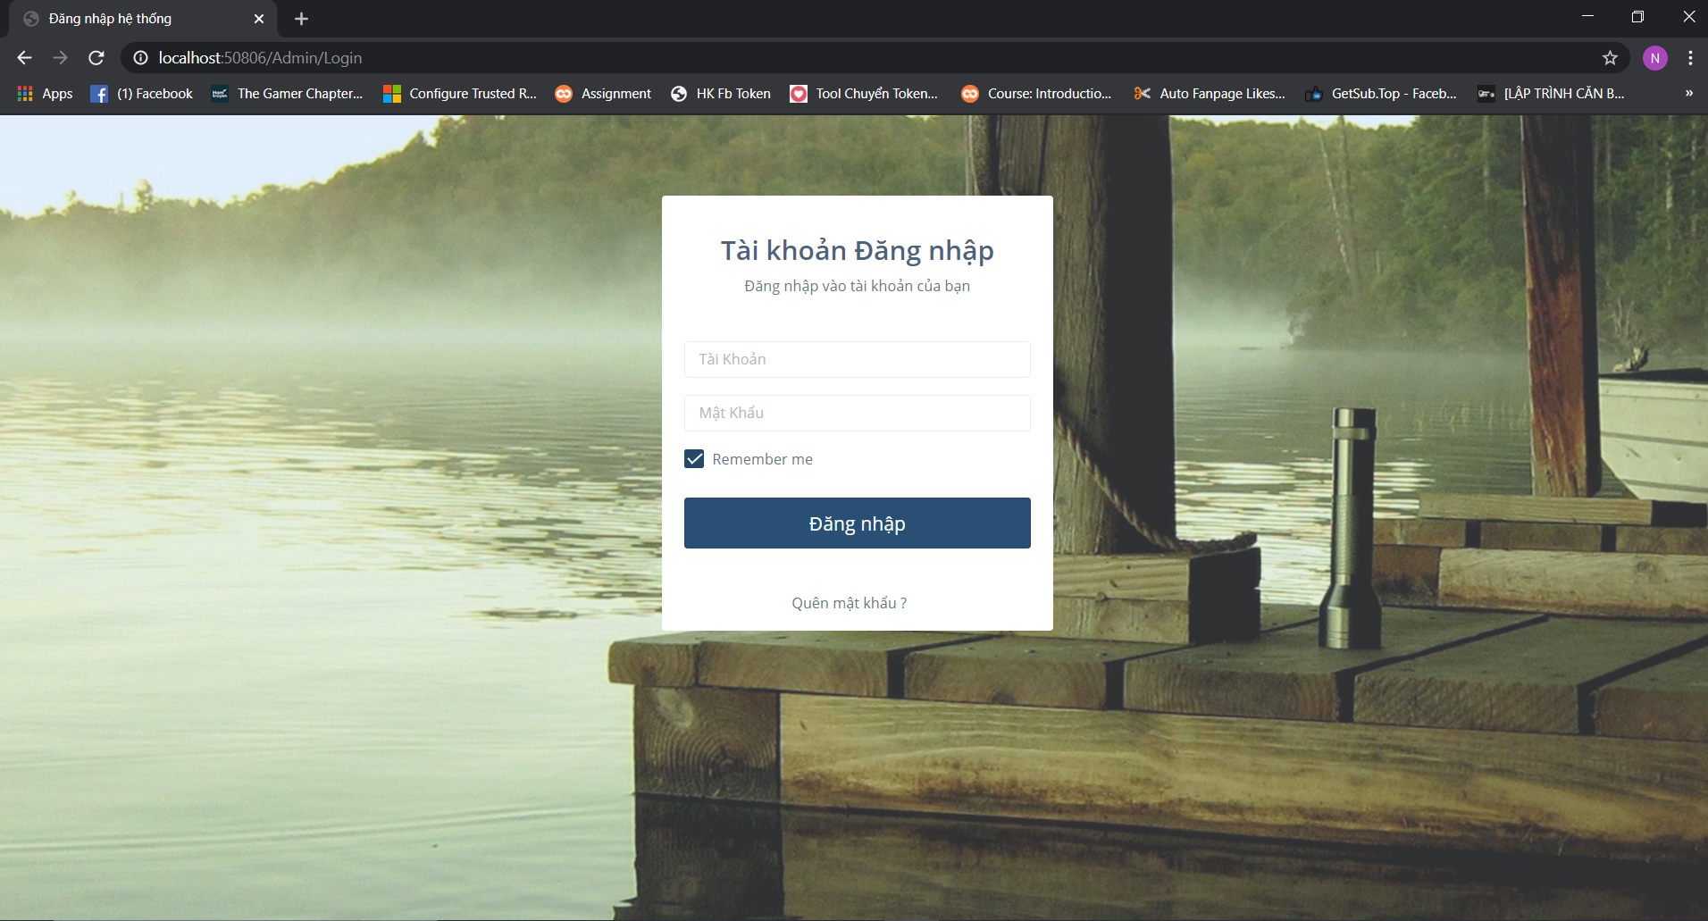

Figure : Page Admin Login

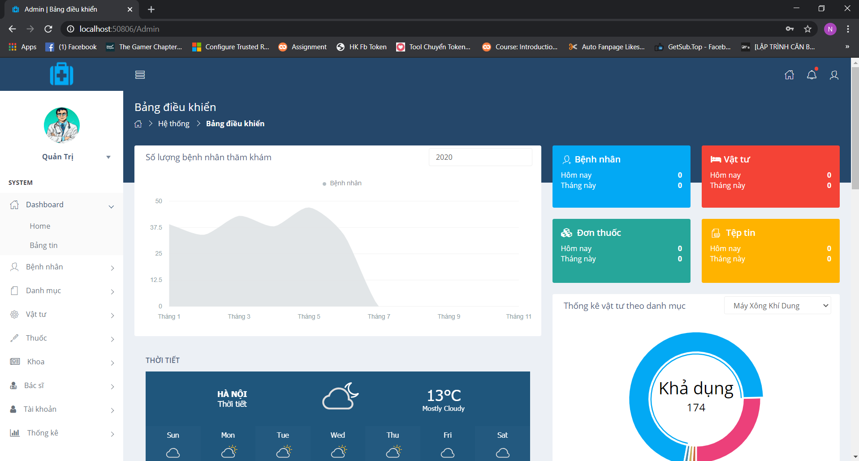

Figure : Interface of admin when log in successful (Admin Page)

The Doctor and Admin can Add, Update and Delete…for Patient, Medicine, Medical Supplies, doctor account, faculty…The patient just can vi

## 3.2 Business Process

### 3.2.1 Process Description

Student Name: Nguyen Truong Hoang Hieu

Table : Process Description

|  |  |  |  |
| --- | --- | --- | --- |
| Step | Description | Person perform | Instructions, Process, Detail data fields |
| 1 | Receive patient information and create a request to add patient records on the system | Administrative worker | Information required to add patient records: - Information about request: Name, Date of Birth, Address, Sex, ID card, phone number, Current status, profile picture, email, Family medical record, Medical profile of the village body, occupation, workplace, patient code, medical record number. |
| 2 | Transfer patient records to departments and doctors corresponding to patient examination requirements | Administrative worker |  |
| 3 | The faculties receive records and request payment of expenses. The patient must have proof of payment | Administrative worker |  |
| 4 | Examination by doctor | Doctor | Doctor information includes: Full name, Phonenumber, Gender,email, Address, Doctor ID, Faculty Code. |
| 5 | The doctor ordered to go for tests, endoscopy, ... | Doctor |  |
| 6 | Based on the test results, doctors make decisions for inpatients or outpatients | Doctor |  |
| 7 | If outpatient, the drug will be prescribed | Doctor | Prescription information:Drug name, medical history code, Prescription code |
| 8 | Distributing and selling drugs to patients | Pharmacist | Prescription details include: Prescription code, Quantity, Notes, Unit. |
| 9 | If inpatient, it will carry out treatment or emergency | Doctor |  |
| 10 | Equipment will be provided to the patient | A nurse | Equipment information includes: Patient ID, Item Name, Date of Borrow, Condition, Item Coupon Code |
| 11 | Patients receive daily treatment such as drug infusion, injection ... | A nurse |  |
| 12 | If the patient is well and has a doctor's consent to discharge, go back to step 7 |  |  |
| 13 | If patient is well and has doctor's consent to discharge, go to step 7 If patient is not well and continue treatment according to doctor's procedure, go to step 9 |  |  |

## 3.3 Business Function Diagram

Student name: Nguyen Tan Loc

### 3.3.1 Identify Function

* List of software detailed functions:

1. Patient add, edit, delete and search function

* Extra function: performed when the patient comes to the hospital for the first time. At that time, the staff will enter the new patient's information and be saved in the database
* Correction function: is performed when the information of one or more patients has changed
* Delete function: is performed when one or more patients have passed the time to save information in the system
* Search function: is performed when the administrator wants to search patient information

After the patient is registered for medical examination, the patient will be generated an examination form. This form of examination is concluded by the doctor after the examination.

2. Function to add medical records (RecordId)

* Additional functions: are performed with all patients who come to post during the examination.

Then, when concluding the patient's existing condition, the doctor must add the process of adding that name to the patient's medical record (Record - the medical record is the record of the medical history. of existing and existing patients)

3. Function add, edit, search medical records (Record)

Additional function: performed for patients who are examined for the first time

Correction function: is performed when the patient has a medical record and adds the name of the disease (if any) that the patient is having.

Search function: is performed when the administrator (doctor) wants to search the patient's medical information

When concluding the patient's illness, the doctor will prescribe the patient's medicine. One patient can have many diseases. Each disease will have a different prescription.

4. Prescription add-on function (DetailPrescription)

Extra function: performed when a patient is found to have an illness and requires drug therapy.

To manage the names of drugs in the drug store or add new drug names, there are the functions:

5. New add function, search the drug name (Medicine)

New add function: is implemented when new drugs are entered into the warehouse

Search function: is performed when the administrator (pharmacist, doctor) wants to check if the name of the drug is in the hospital's drug store.

Each patient (inpatient) will be accompanied by medical supplies equipped to support treatment in that hospital.

6. Function to add, update medical supplies (Item)

Additional functionality: performed when adding new medical supplies

Update function: is performed when the manager wants to know the remaining quantity of medical supplies that can be serviced by other patients.

Each medical material belongs to a different group. The following functions are available:

7. Function to add new groups (Category)

New added function: adding new group of medical supplies

### 3.3.2 BDF

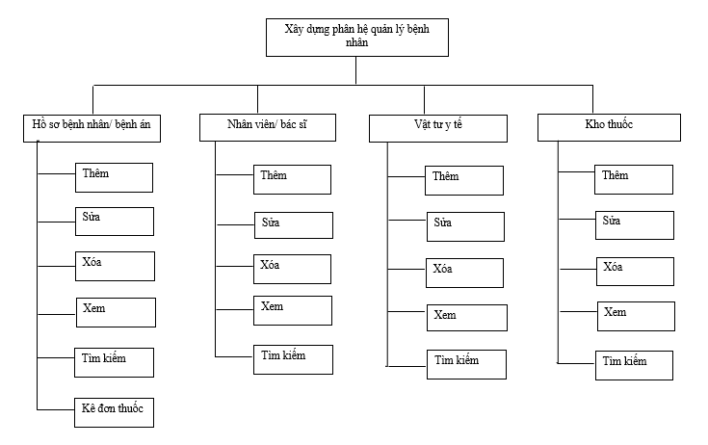

Figure : Bussiness Diagram Function

### 3.3.3 Non-functional requirement

- Accuracy constraint: Functions must operate according to set requirements, information must be complete and accurate.

- Usability constraints: Interface is easy to learn, easy to use.

- Confidence trust: Few errors. Ability to handle and fault tolerance. Allows the user to detect and resolve most problems by themselves.

- Constraint for data integrity and consistency

- Ability to expand, develop into large systems

- Large storage capacity (Tested with 1000 records)

- Confidentiality constraints: Employee information (date of birth, salary, contract, ...) is sensitive information that needs to be kept confidential. Decentralization, authentication of user identity. There is a form of action if information is disclosed to follow

- Level of influence, impact.

- Flexibly work under any type of organizational structure and employee hierarchy.

- The ability to backup and restore data.

- Easy to install, deploy and maintain the system (the ability to test, upgrade, change and develop software to suit new requirements, functions and environments)

## 3.4 Use case diagram

### 3.4.1 General use case diagram

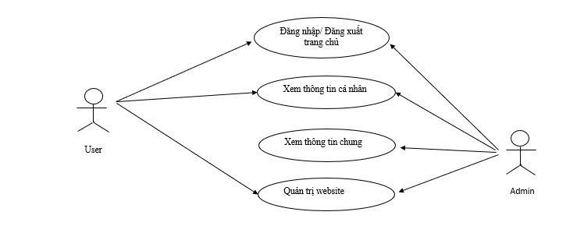

Figure : General use case diagram

### 3.4.2 Use case specification

Table : Login use case

|  |  |  |  |  |
| --- | --- | --- | --- | --- |
| **Super Use Case** |  | | |  |
| **Author** | Nguyễn Văn A | | |  |
| **Date** | 20/07/2000 | | |  |
| **Brief Description** | User login to the system | | |  |
| **Preconditions** | The system is not logged in | | |  |
| **Post – conditions** | Users are accessing the system, choose to log in by entering an account, password and then send it to the authentication system.  - If correct information returns, login successfully  - If incorrect information returns, login failure | | |  |
| **Flow of Events** |  | **Actor Input** | **System Response** | |
| 1 | Press Login |  | |
| 2 |  | Display form Login. Require login information | |
| 3 | Enter the Username and Password in the form. Click the "Login" button. |  | |
| 4 |  | Check the validity of the login information. If wrong, ask to re-enter. Otherwise, login is successful. | |
| 5 | Repeat thread 3 if the system reports an invalid error |  | |
| 6 |  | Repeat stream 4 until the information entered from the user is valid | |
| 7 |  | Go back Homepage | |

Table : Add patient information

|  |  |  |  |
| --- | --- | --- | --- |
| **Super Use Case** |  | | |
| **Author** | Nguyễn Văn A | | |
| **Date** | 20/07/2000 | | |
| **Brief Description** | The user adds a new patient. | | |
| **Preconditions** | User must log in to the system with administrator privileges | | |
| **Post – conditions** | If the function is successful, display the resource management interface | | |
| **Flow of Events** |  | **Actor Input** | **System Response** |
| 1 | At the main interface, button "Add" |  |
| 2 |  | Display the form to add a new patient |
| 3 | Enter complete patient information. |  |
| 4 | 1.Press the button "Save to medical record".  2. Click the button "Cancel" |  |
| 5 |  | 1.The system notifies successfully adding and ending use-case.  2. Add patient failed. |

Table : Update patient information

|  |  |  |  |
| --- | --- | --- | --- |
| **Super Use Case** |  | | |
| **Author** | Nguyễn Văn A | | |
| **Date** | 20/07/2000 | | |
| **Brief Description** | User corrects patient information. | | |
| **Preconditions** | User must log in to the system with administrator privileges | | |
| **Post – conditions** | If the function is successful, display the resource management interface | | |
| **Flow of Events** |  | **Actor Input** | **System Response** |
| 1 | At the patient list interface, click to select the patient you want to edit |  |
| 2 |  | Display form allows to edit new patient information |
| 3 | Edit patient information |  |
| 4 | Edit patient information  1. Press the button “Save” 2. Click the button "Cancel" |  |
| 5 |  | 1.The system notifies successful repair and end of use-case.  2. Repair failed patient. |

Table : Delete patient information

|  |  |  |  |
| --- | --- | --- | --- |
| **Super Use Case** |  | | |
| **Author** | Nguyễn Văn A | | |
| **Date** | 20/07/2000 | | |
| **Brief Description** | User deletes patient information. | | |
| **Preconditions** | User must log in to the system with administrator privileges | | |
| **Post – conditions** | If the function is successful, display the resource management interface | | |
| **Flow of Events** |  | **Actor Input** | **System Response** |
| 1 | If the function is successful, display the resource management interface At the patient list interface, click to select the patient you want to delete. |  |
| 2 |  | Displays a popup to confirm whether to delete a patient. |
|
| 4 | 1.Press the "Oke" button. 2. Click the button "Cancel" |  |
| 5 |  | 1.The system notifies the successful deletion and end use-case. 2. Unsuccessful patient deletion. |

Table : Add doctor information

|  |  |  |  |
| --- | --- | --- | --- |
| **Super Use Case** |  | | |
| **Author** | Nguyễn Văn A | | |
| **Date** | 20/07/2000 | | |
| **Brief Description** | User added to doctor information. | | |
| **Preconditions** | User must log in to the system with administrator privileges | | |
| **Post – conditions** | If the function is successful, display the resource management interface | | |
| **Flow of Events** |  | **Actor Input** | **System Response** |
| 1 | At the main interface, button "Add" |  |
| 2 |  | Display form allows to add a new doctor information |
| 3 | Enter the full information of the doctor |  |
| 4 | 1.Press the "Save" button. 2. Click the button "Cancel" |  |
| 5 |  | 1.The system notifies successfully adding and ending use-case.  2. Adding doctor failed. |

Table : Update doctor information

|  |  |  |  |
| --- | --- | --- | --- |
| **Super Use Case** |  | | |
| **Author** | Nguyễn Văn A | | |
| **Date** | 20/07/2000 | | |
| **Brief Description** | User edit doctor information. | | |
| **Preconditions** | User must log in to the system with administrator privileges | | |
| **Post – conditions** | If the function is successful, display the resource management interface | | |
| **Flow of Events** |  | **Actor Input** | **System Response** |
| 1 | At the doctor list interface |  |
| 2 |  | Display form to edit doctor information |
| 3 | Edit patient information |  |
| 4 | 1.Press the "Save" button. 2. Click the button "Cancel" |  |
| 5 |  | 1.The system notifies successful repair and end of use-case.  2. Repair failed patient. |

Table : Delete doctor information

|  |  |  |  |
| --- | --- | --- | --- |
| **Super Use Case** |  | | |
| **Author** | Nguyễn Văn A | | |
| **Date** | 20/07/2000 | | |
| **Brief Description** | User deletes doctor information. | | |
| **Preconditions** | User must log in to the system with administrator privileges | | |
| **Post – conditions** | If the function is successful, display the resource management interface | | |
| **Flow of Events** |  | **Actor Input** | **System Response** |
| 1 | If the function is successful, display the resource management interface At the patient list interface, click to select the patient you want to delete. |  |
| 2 |  | Displays a popup to confirm whether to remove the doctor. |
|
| 4 | 1.Press the "Oke" button. 2. Click the button "Cancel" |  |
| 5 |  | 1.The system notifies the successful deletion and end use-case. 2. Doctor deletion failed. |

Table : Add medical supplies

|  |  |  |  |
| --- | --- | --- | --- |
| **Super Use Case** |  | | |
| **Author** | Nguyễn Văn A | | |
| **Date** | 20/07/2000 | | |
| **Brief Description** | User added information to medical supplies | | |
| **Preconditions** | User must log in to the system with administrator privileges | | |
| **Post – conditions** | If the function is successful, display the resource management interface | | |
| **Flow of Events** |  | **Actor Input** | **System Response** |
| 1 | At the main interface, button "Add" |  |
| 2 |  | Display form allows to add a new medical supplies information |
| 3 | Enter full information for new medical supplies |  |
| 4 | 1.Press the "Save" button. 2. Click the button "Cancel" |  |
| 5 |  | 1.The system notifies successfully adding and ending use-case.  2. Adding medical supplies failed. |

Table : Update medical supplies

|  |  |  |  |
| --- | --- | --- | --- |
| **Super Use Case** |  | | |
| **Author** | Nguyễn Văn A | | |
| **Date** | 20/07/2000 | | |
| **Brief Description** | User corrects information of medical supplies. | | |
| **Preconditions** | User corrects information of medical supplies. User must login to the system with administrator rights | | |
| **Post – conditions** | If the function is successful, display the resource management interface | | |
| **Flow of Events** |  | **Actor Input** | **System Response** |
| 1 | At the medical supplies list interface |  |
| 2 |  | Display form allows to edit information of medical supplies |
| 3 | Edit medical supplies information |  |
| 4 | 1.Press the "Save" button. 2. Click the button "Cancel" |  |
| 5 |  | 1.The system notifies successful repair and end of use-case.  2. Unsuccessful correction of medical supplies information. |

Table : Delete medical supplies

|  |  |  |  |
| --- | --- | --- | --- |
| **Super Use Case** |  | | |
| **Author** | Nguyễn Văn A | | |
| **Date** | 20/07/2000 | | |
| **Brief Description** | User deletes information from medical supplies. | | |
| **Preconditions** | User must log in to the system with administrator privileges | | |
| **Post – conditions** | If the function is successful, display the resource management interface | | |
| **Flow of Events** |  | **Actor Input** | **System Response** |
| 1 | In the list of supplies interface, click to select the supplies you want to delete |  |
| 2 |  | Display a popup confirming whether to remove medical supplies or not. |
|
| 4 | 1.Press the "Oke" button. 2. Click the button "Cancel" |  |
| 5 |  | 1.The system notifies the successful deletion and end use-case. 2. Deletion of medical supplies failed. |

## 3.5 Design Database

Student Name: Nguyen Tan Loc

### 3.5.1 Database Diagram

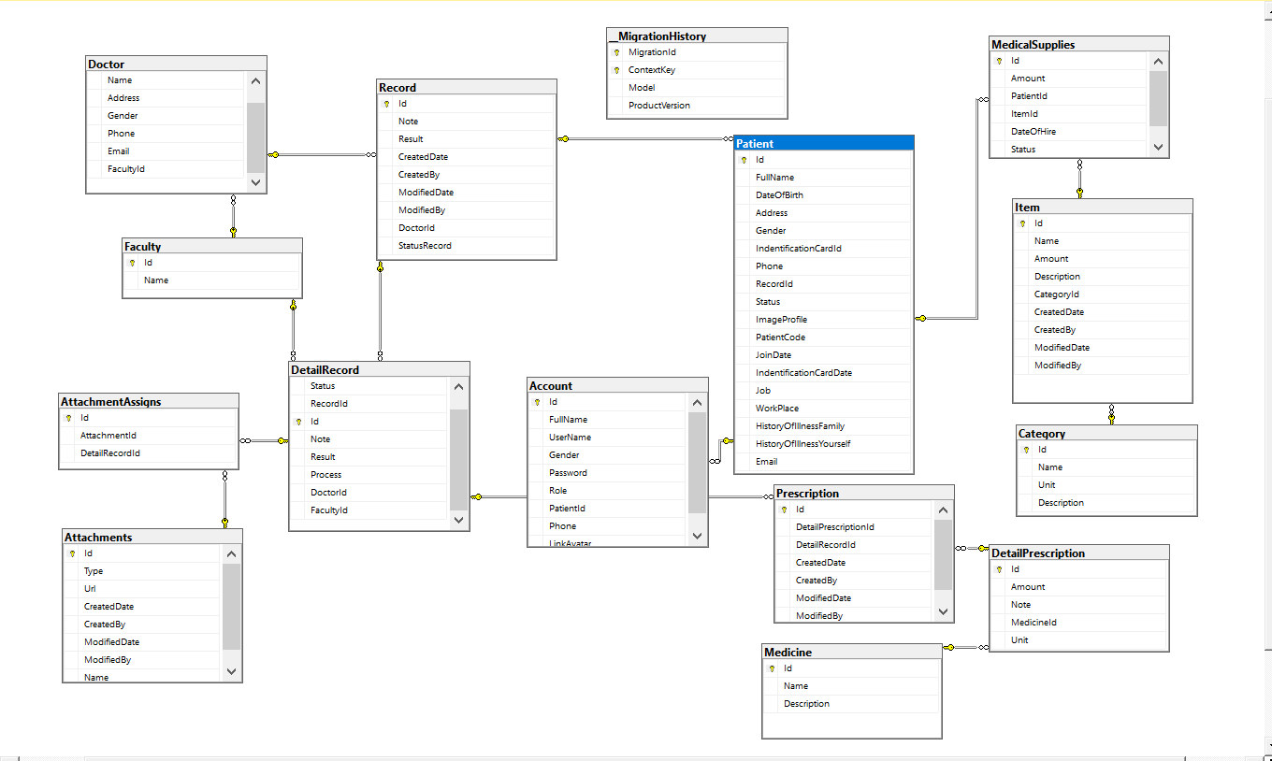

Figure : Database Diagram

### 3.5.2 Database Specification and Field Decsription

Table : Patient

|  |  |  |
| --- | --- | --- |
| Tên trường | Kiểu dữ liệu | Ràng buộc |
| ID | uniqueidentifier | Primary key |
| FullName | nvarchar(100) |  |
| Address | Nvarchar(250) |  |
| Gender | Bit |  |
| IndentificationCardId | Varchar(12) |  |
| Phone | Varchar(12) |  |
| Reason | nvarchar(255) |  |
| RecordId | uniqueidentifier |  |
| Status | Bit |  |
| ImageProfile | Nvarchar(Max) |  |
| PatientCode | Nvarchar(Max) |  |
| JoinDate | Datetime2(7) |  |
| IndentificationCardDate | datetime |  |
| Job | Nvarchar(Max) |  |
| WorkPlace | Nvarchar(Max) |  |
| HistoryOfIllnessFamily | Nvarchar(Max) |  |
| HistoryOfIllnessYourself | Nvarchar(Max) |  |
| Email | Nvarchar(250) |  |

Table : Prescription

|  |  |  |
| --- | --- | --- |
| Tên trường | Kiểu dữ liệu | Ràng buộc |
| ID | uniqueidentifier | Primary key |
| DetailPrescriptionId | uniqueidentifier |  |
| DetailRecordId | uniqueidentifier |  |
| CreatedDate | datetime |  |
| CreatedBy | nvarchar(MAX) |  |
| ModifiedDate | datetime |  |
| ModifiedBy | nvarchar(MAX) |  |

Table : DetailPrescription

|  |  |  |
| --- | --- | --- |
| Tên trường | Kiểu dữ liệu | Ràng buộc |
| ID | uniqueidentifier | Primary key |
| Amount | int |  |
| Medicineld | uniqueidentifier |  |
| Unit | Nvarchar(50) |  |
| Note | Nvarchar(Max) |  |

Table : Record

|  |  |  |
| --- | --- | --- |
| Tên trường | Kiểu dữ liệu | Ràng buộc |
| ID | uniqueidentifier | Primary key |
| Note | Nvarchar(Max) |  |
| Result | Nvarchar(Max) |  |
| CreatedDate | datetime |  |
| CreateBy | Nvarchar(Max) |  |
| ModifiedDate | datetime |  |
| ModifiedBy | Nvarchar(Max) |  |
| DoctorID | uniqueidentifier | Foreign key |
| StatusRecord | int |  |

Table : DetailRecord

|  |  |  |
| --- | --- | --- |
| Tên trường | Kiểu dữ liệu | Ràng buộc |
| ID | uniqueidentifier | Primary key |
| status | bit |  |
| DiseaseName | Nvarchar(200) |  |
| RecordID | uniqueidentifier |  |
| DoctorID | uniqueidentifier | Foreign key |
| FcultyID | uniqueidentifier | Foreign key |
| Result | Nvarchar(Max) |  |
| Process | int |  |
| Note | Nvarchar(Max) |  |

Table : Medicine

|  |  |  |
| --- | --- | --- |
| Tên trường | Kiểu dữ liệu | Ràng buộc |
| ID | uniqueidentifier | Primary key |
| Name | Nvarchar(200) |  |
| Description | Nvarchar(Max) |  |

Table : Vat tu (Item)

|  |  |  |
| --- | --- | --- |
| Tên trường | Kiểu dữ liệu | Ràng buộc |
| ID | uniqueidentifier | Primary key |
| Name | Nvarchar(250) |  |
| Amount | int |  |
| Description | Nvarchar(Max) |  |
| CategoryId | uniqueidentifier | Foreign key |
| CreatedDate | datetime |  |
| CreatedBy | nvarchar(MAX) |  |
| ModifiedDate | datetime |  |
| ModifiedBy | nvarchar(MAX) |  |

Table : MedicalSupplies

|  |  |  |
| --- | --- | --- |
| Tên trường | Kiểu dữ liệu | Ràng buộc |
| ID | uniqueidentifier | Primary key |
| Amount | int |  |
| PatientID | uniqueidentifier | Foreign key |
| ItemID | uniqueidentifier | Foreign key |
| DateOfHire | datetime |  |
| Status | bit |  |

Table : Category

|  |  |  |
| --- | --- | --- |
| Tên trường | Kiểu dữ liệu | Ràng buộc |
| Id | uniqueidentifier | Primary key |
| Name | nvarchar(MAX) | Foreign key |
| Unit | nvarchar(50) |  |
| Description | nvarchar(MAX) |  |

Table : Faculty

|  |  |  |
| --- | --- | --- |
| Tên trường | Kiểu dữ liệu | Ràng buộc |
| ID | int | Primary key |
| Name | nvarchar(MAX) | Foreign key |

Table : Doctor

|  |  |  |
| --- | --- | --- |
| Tên trường | Kiểu dữ liệu | Ràng buộc |
| ID | uniqueidentifier | Primary key |
| Name | nvarchar(MAX) |  |
| Gender | bit |  |
| Phone | nvarchar(MAX) |  |
| Email | nvarchar(MAX) |  |
| FacultyId | uniqueidentifier |  |

Table : Account

|  |  |  |
| --- | --- | --- |
| Tên trường | Kiểu dữ liệu | Ràng buộc |
| ID | int | Primary key |
| FullName | nvarchar(50) |  |
| UserName | nvarchar(50) |  |
| Gender | bit |  |
| Password | nvarchar(250) |  |
| Role | int |  |
| PatientId | uniqueidentifier | Foreign key |
| Phone | nvarchar(15) |  |
| LinkAvatar | nvarchar(250) |  |

Table : AttachmentAssigns

|  |  |  |
| --- | --- | --- |
| Tên trường | Kiểu dữ liệu | Ràng buộc |
| Id | uniqueidentifier | Primary key |
| AttachmentId | uniqueidentifier | Foreign key |
| DetailRecordId | uniqueidentifier |  |

Table : Attachments

|  |  |  |
| --- | --- | --- |
| Tên trường | Kiểu dữ liệu | Ràng buộc |
| Id | uniqueidentifier | Primary key |
| Type | nvarchar(MAX) | Foreign key |
| Url | nvarchar(MAX) |  |
| CreatedDate | datetime |  |
| CreatedBy | nvarchar(MAX) |  |
| ModifiedDate | datetime |  |
| ModifiedBy | nvarchar(MAX) |  |
| Name | nvarchar(MAX) |  |

# Chapter 4: Install and Test

Student Name: Nguyen Tan Loc

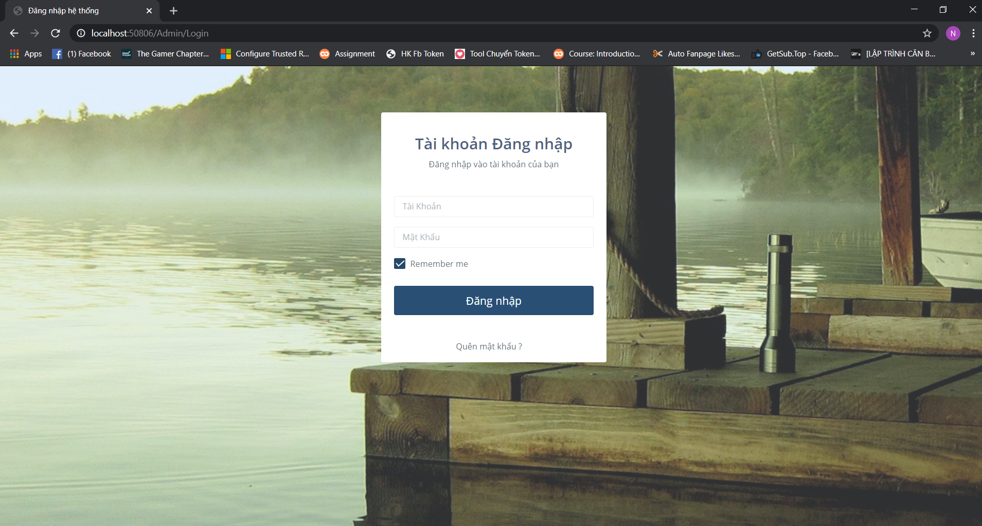

Figure : Page for admin login

To ensure security, users need to log in to access the system. For administrators, the administrator with the highest authority will have the right to add the admin account and view the list of users.

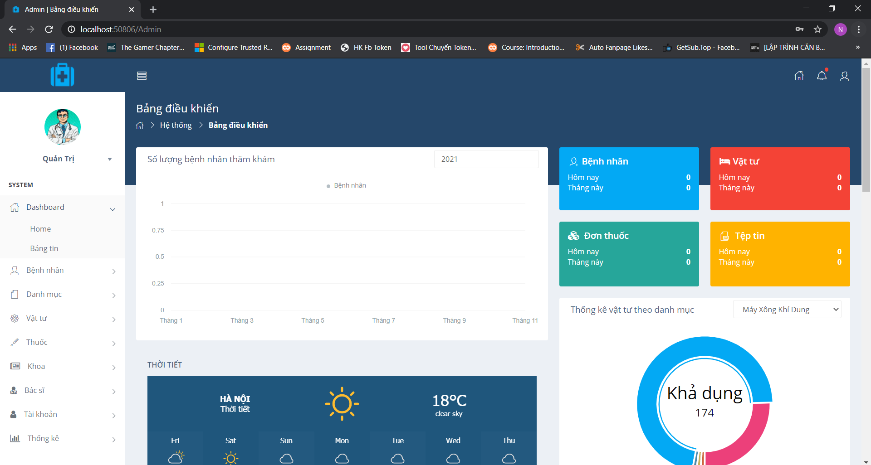

Figure : Dashboad of admin

The Dashboad homepage quickly shows you the number of requests managed by status

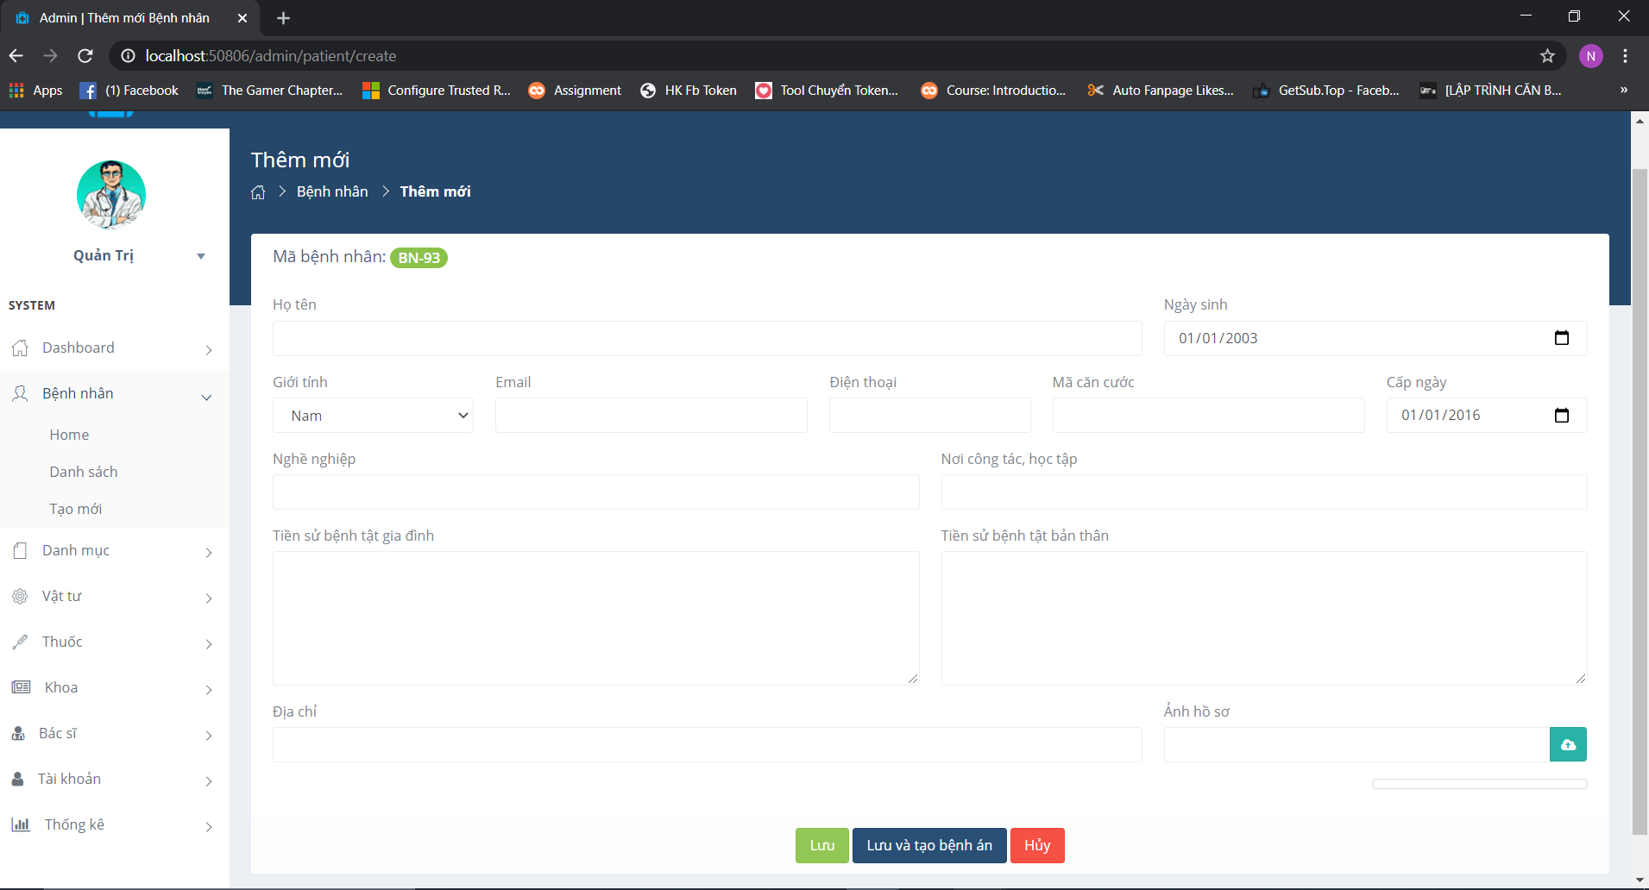

Figure Page add patient

Admin click Bệnh Nhân => Choose Tạo mới. The page add patient will display.

Admin or doctor will add information for patient and click save that save patient information

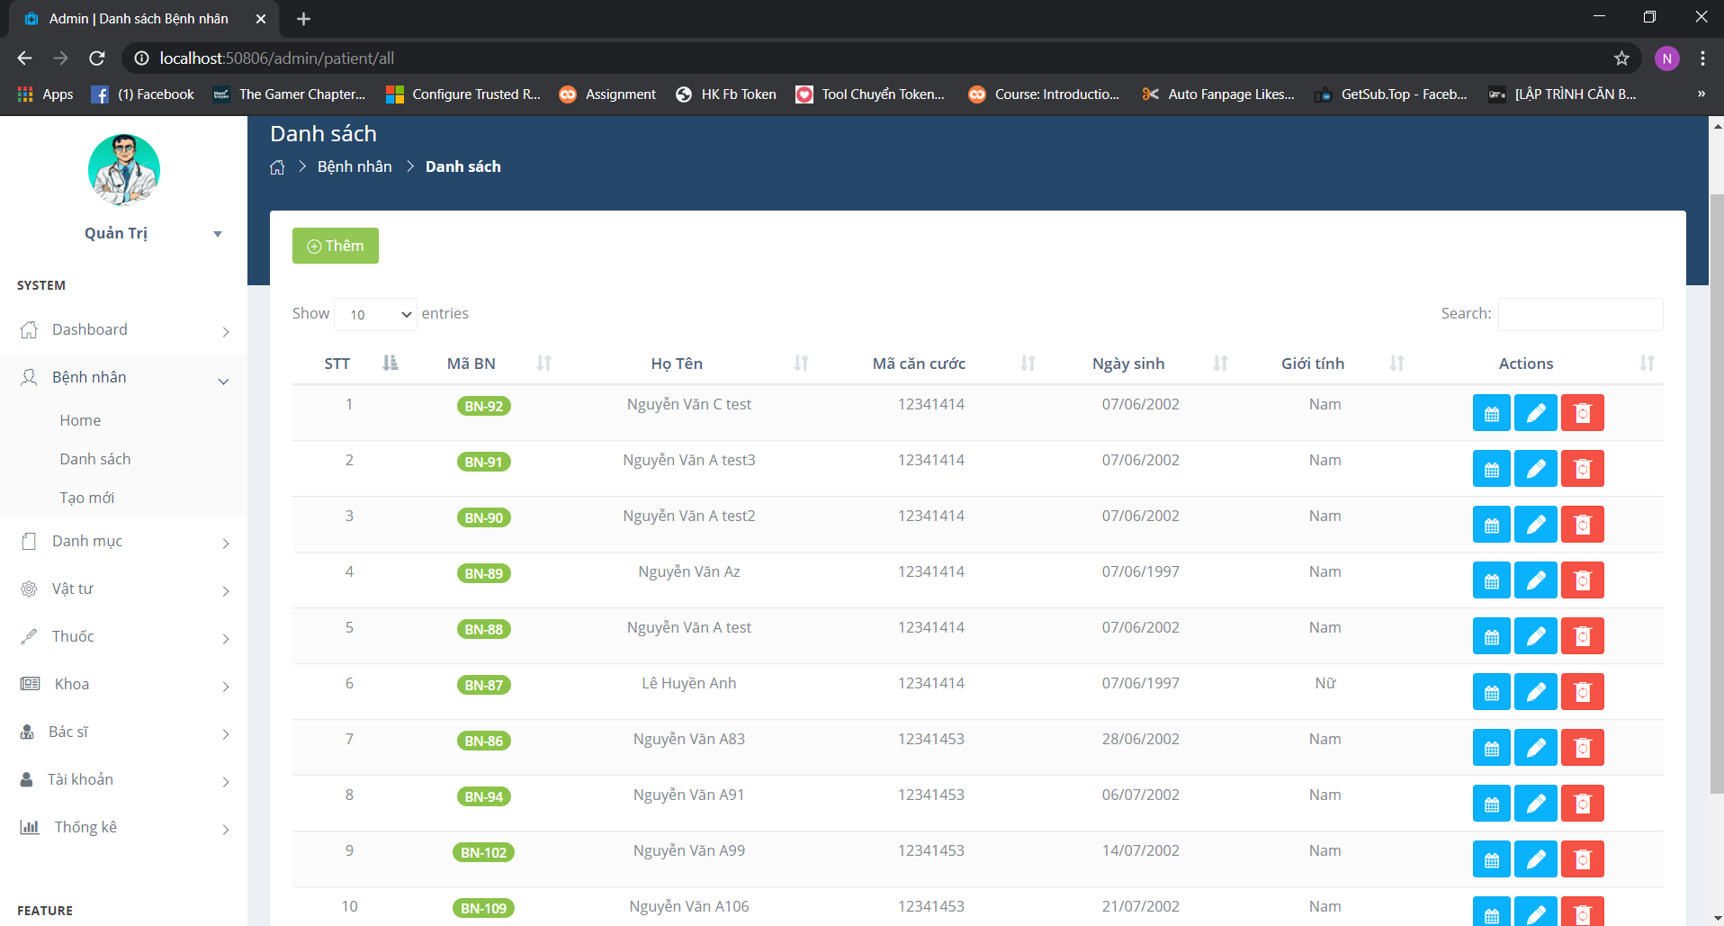

Figure : Page show a list of patient

Admin click Bệnh Nhân => Choose Danh sách. The page show all patient.

After add patient information, the figure 14 show all patient. Admin can see detail information, update and delete patient

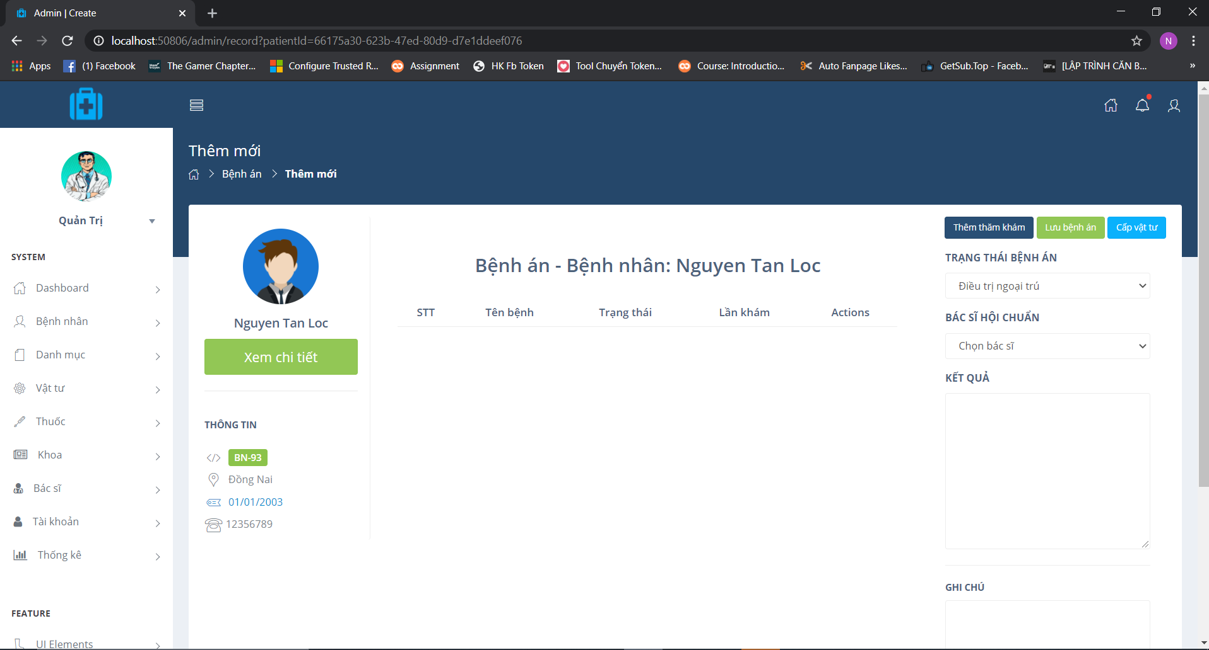

Figure : Page show detail information of patient

Admin click Bệnh Nhân => Choose Danh sách. The page show all patient.

After admin add successful, admin click Xem benh an button

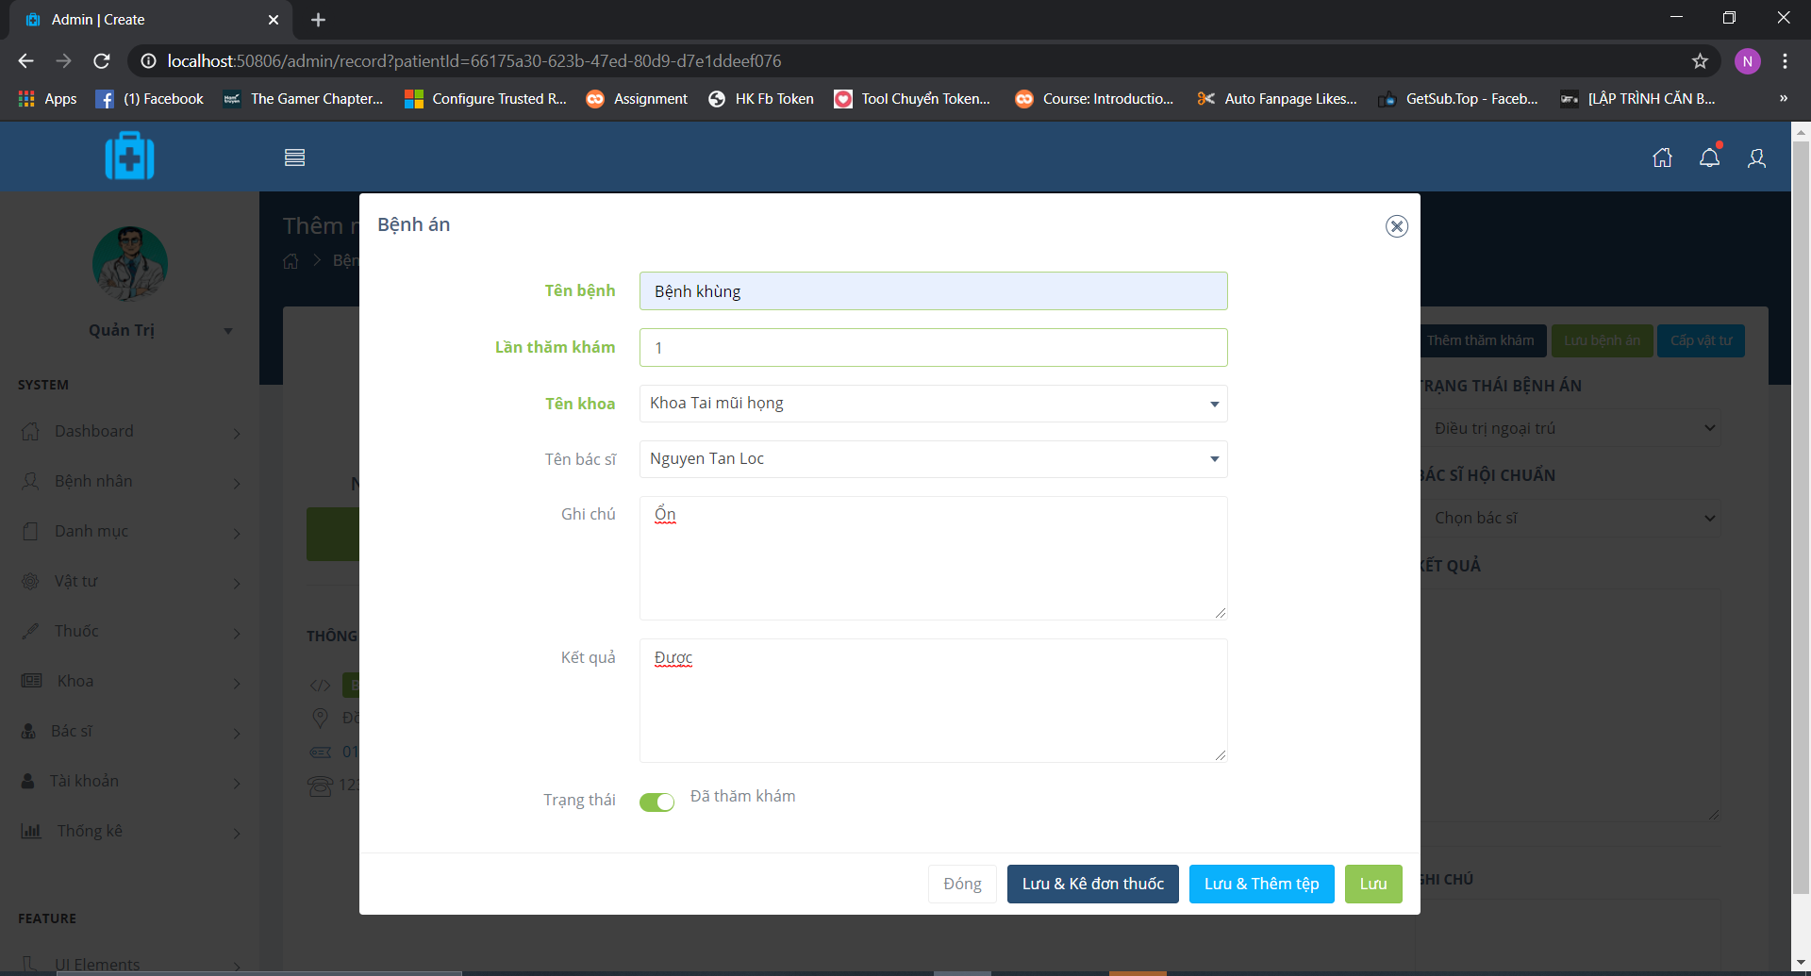

Figure : Add visit for patient

Doctor visit patient and check the patient health. A admin note number of visit

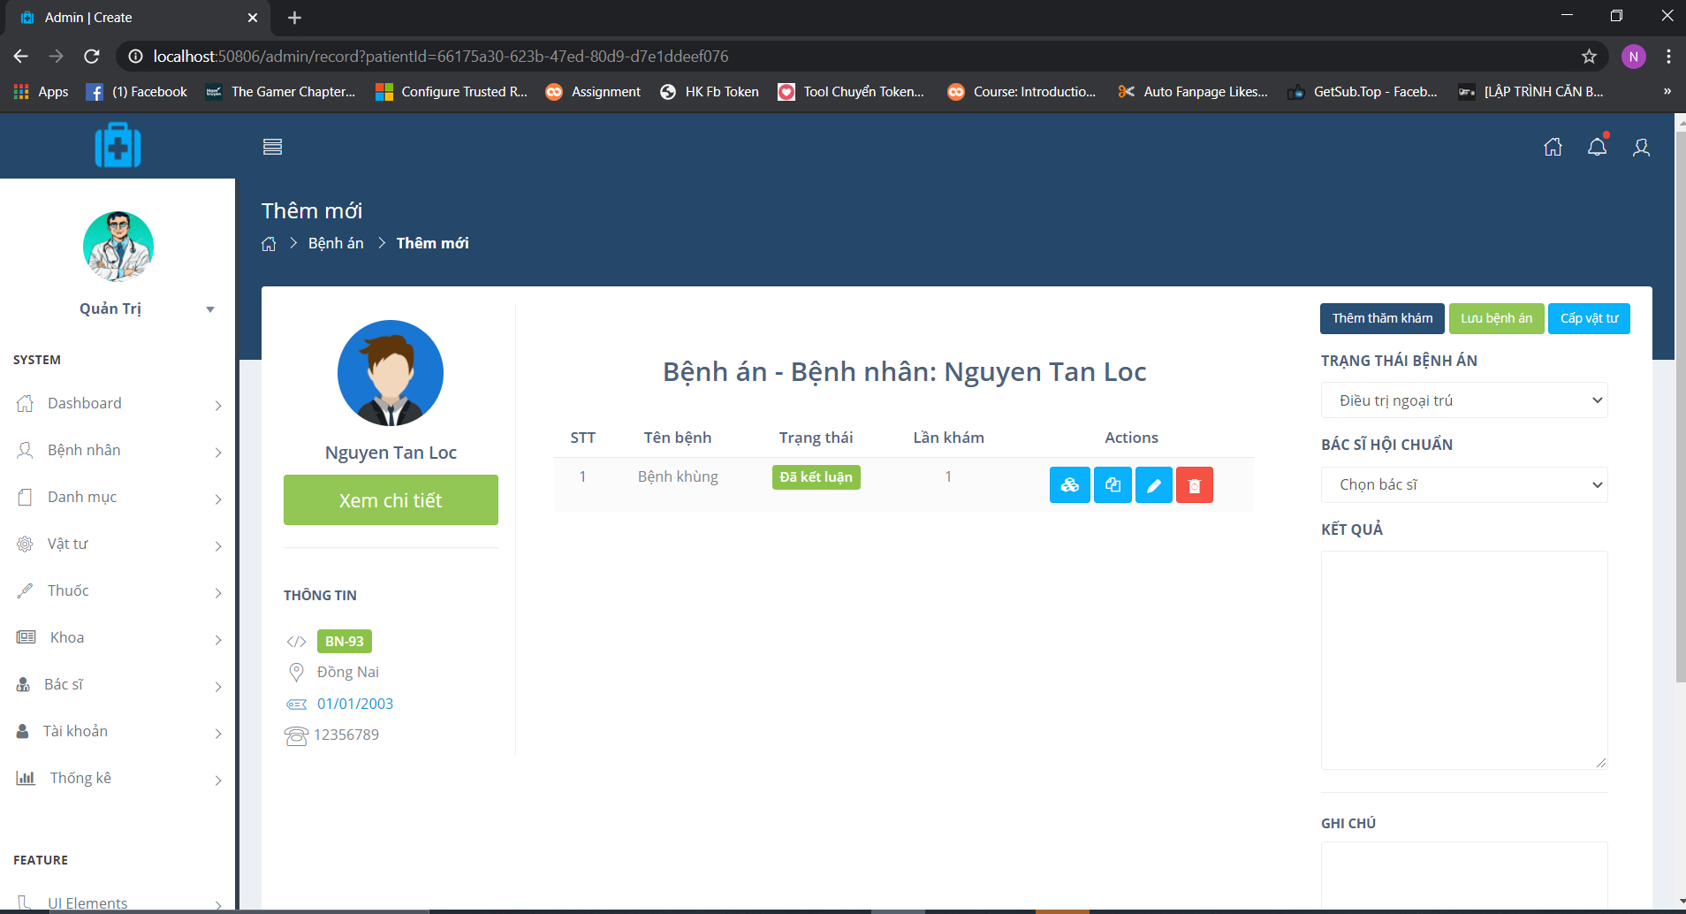

Figure : Save successful

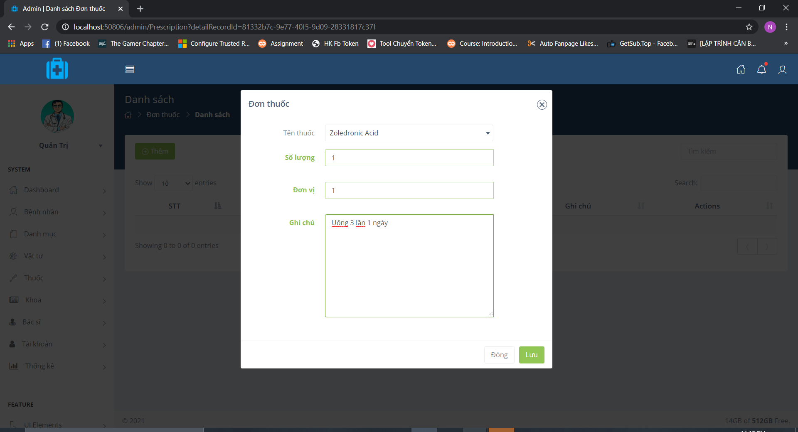

Figure : Add medical for patient

Doctor or admin can add medical for patient

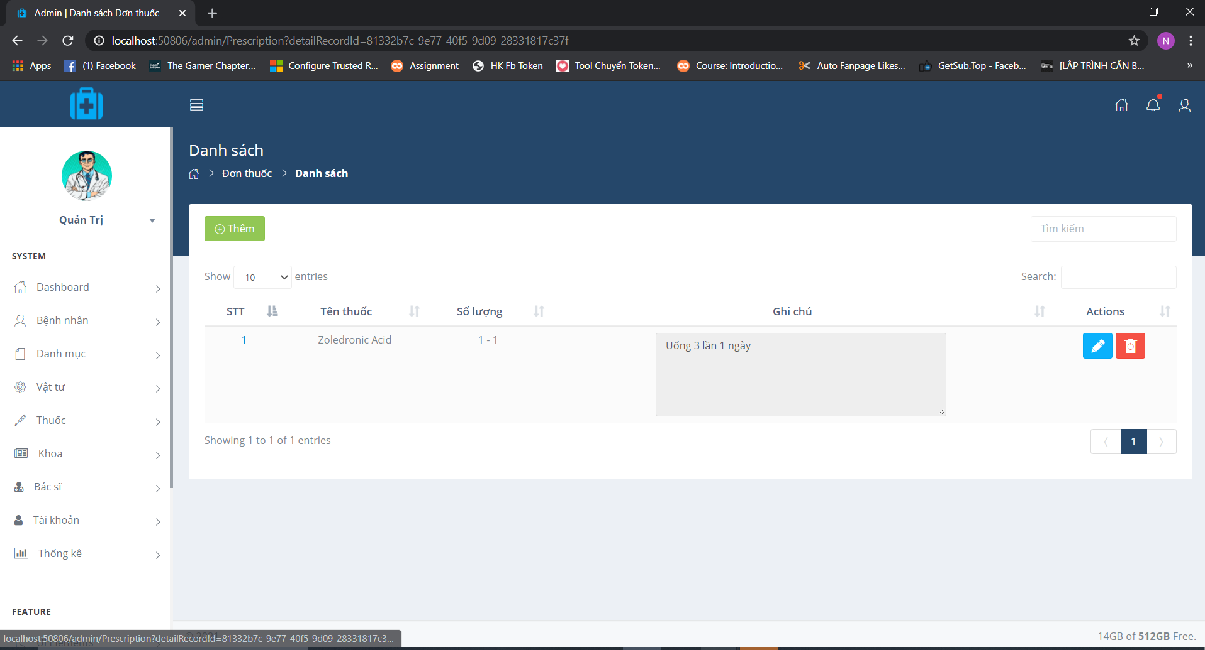

Figure : Add successful

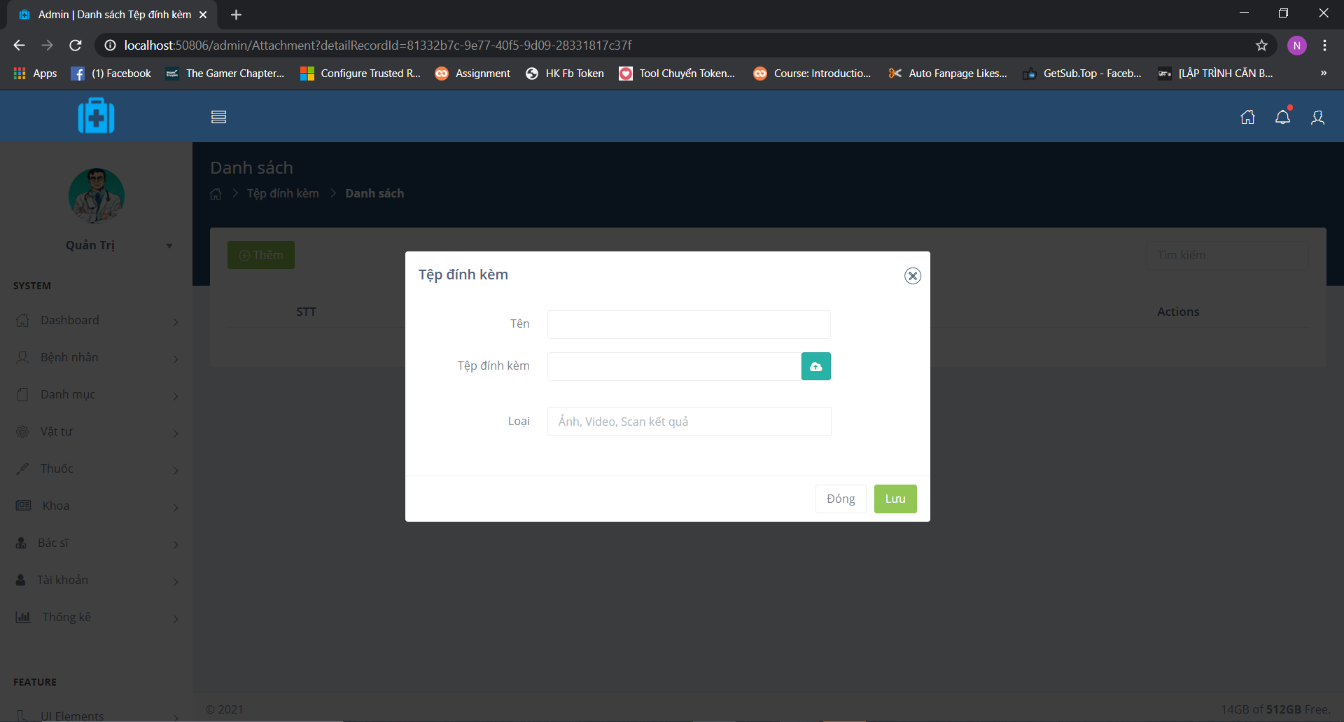

Figure : Add image, video, scan result

Admin or doctor can add image, video, scan result for patient

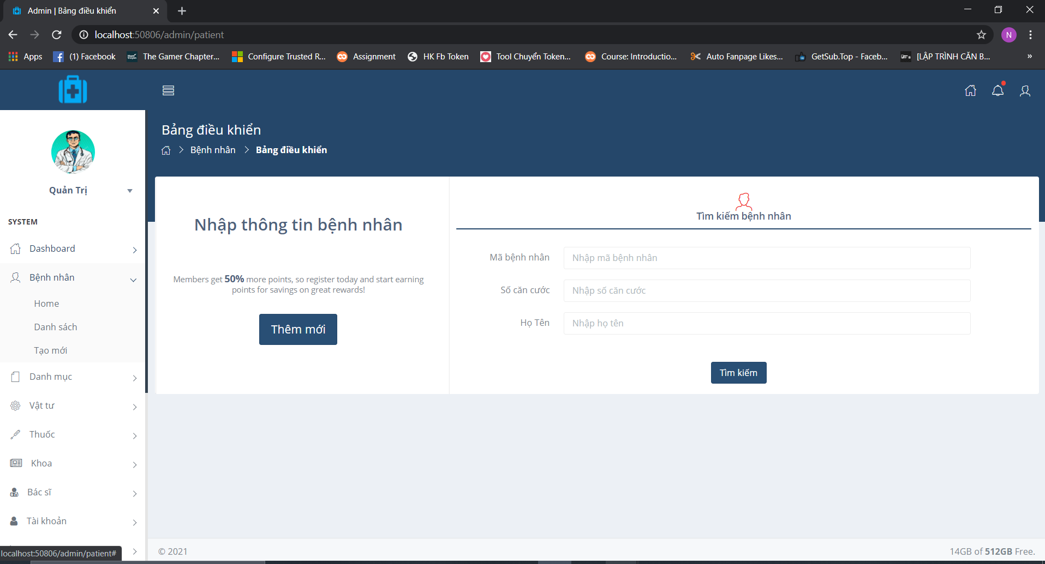

Figure : Page search patient

Admin click Bệnh Nhân => Choose Home. The page search patient will display.

Input ID patient, identitycation number and name that search patient

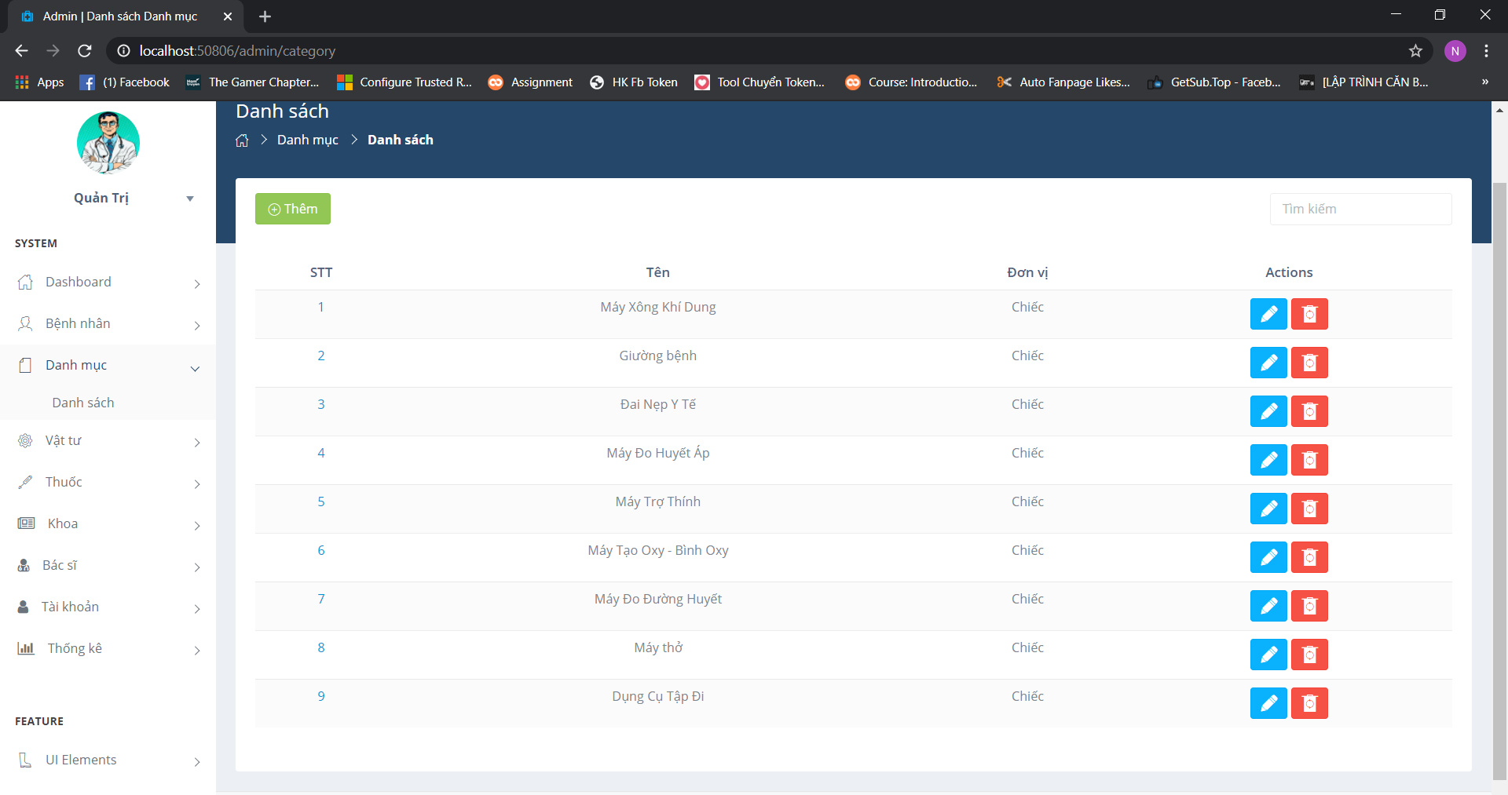

Figure Page show list of medical supplies

Admin click Danh mục => Choose Danh sách. List of medical supplies will be displayed.

The page show list of medical supplies and admin can add medical supplies

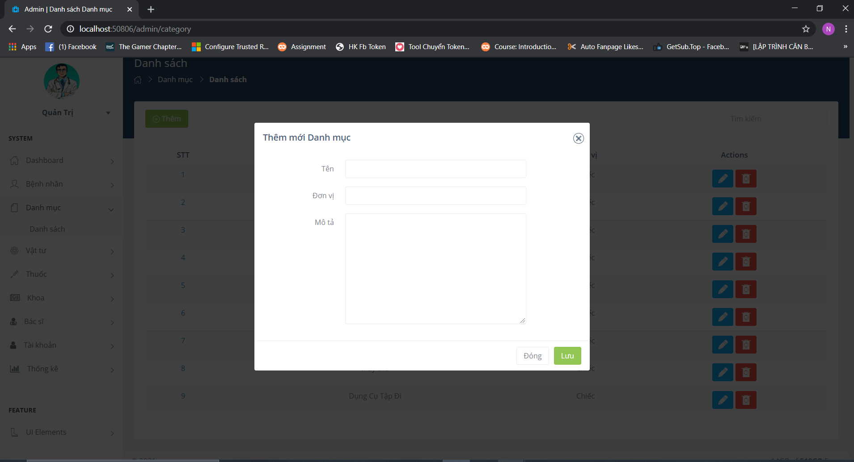

Figure : Page show list of medical supplies

After admin click add button. The page will show add medical supplies and admin can input new supplies information

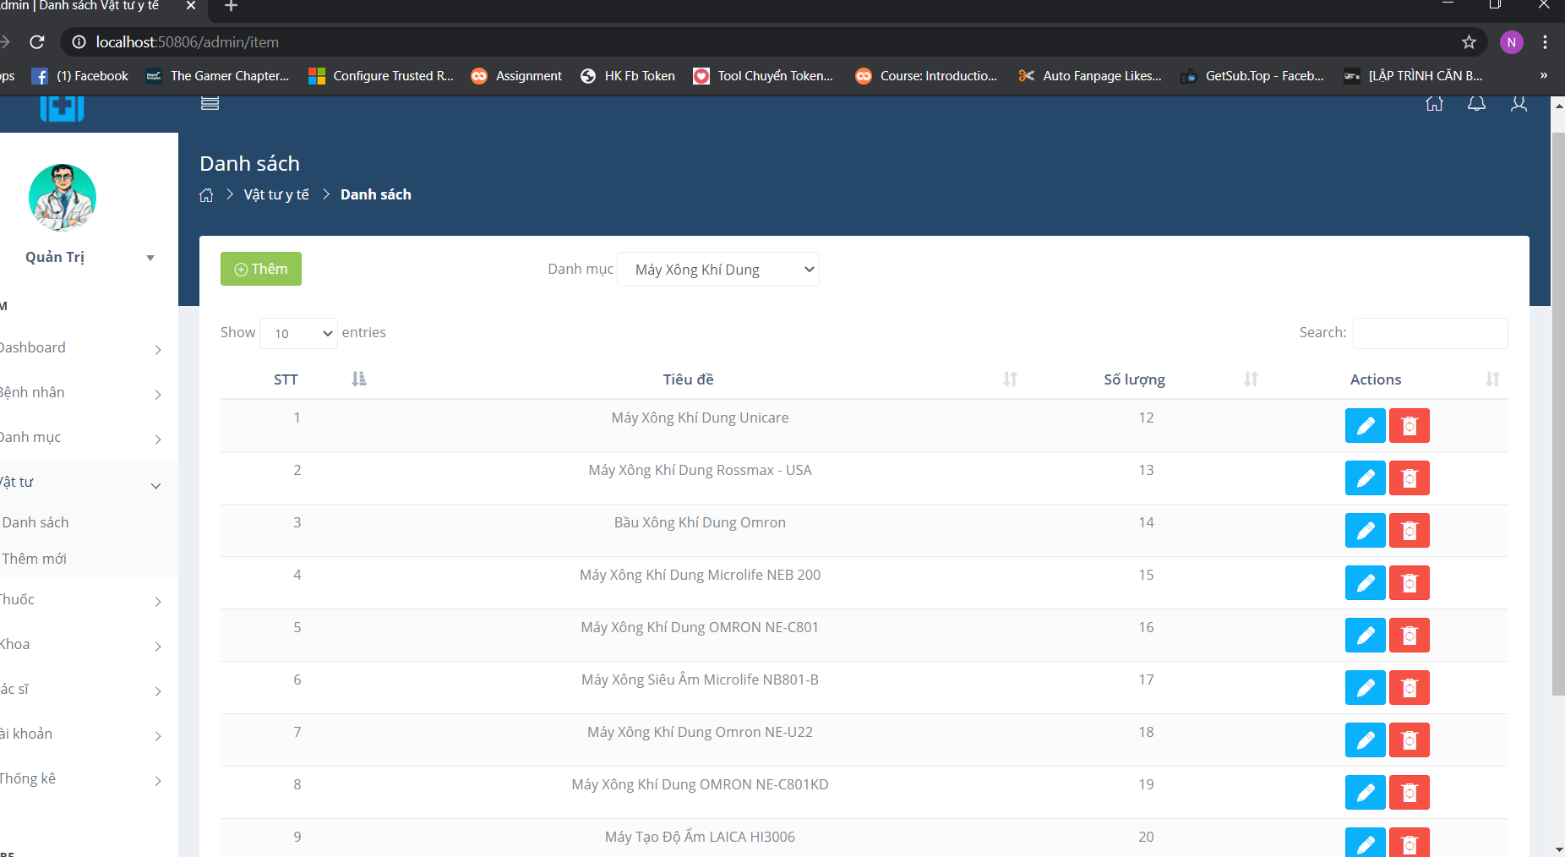

Figure : Page medical supplies

Admin click Vat tu => Choose Danh sach.

The page show all type medical supplies in one supplies. Admin can update that repair title and number and delete supplies

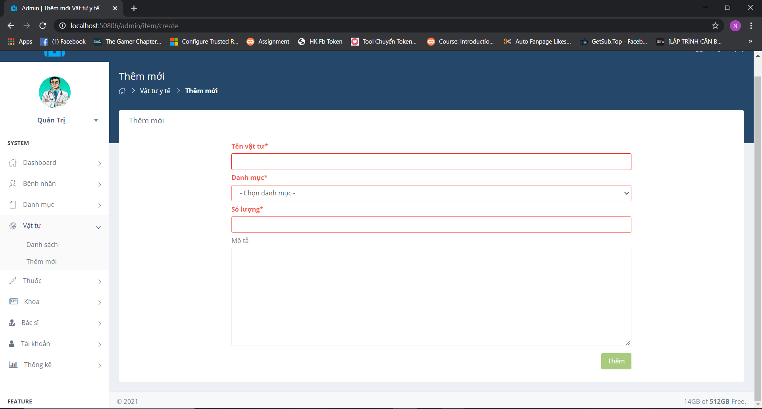

Figure : Page add new medical supplies

Admin click Vat tu => Choose Them moi. The page show add new medical supplies

Admin input information of new medical supplies and click Them

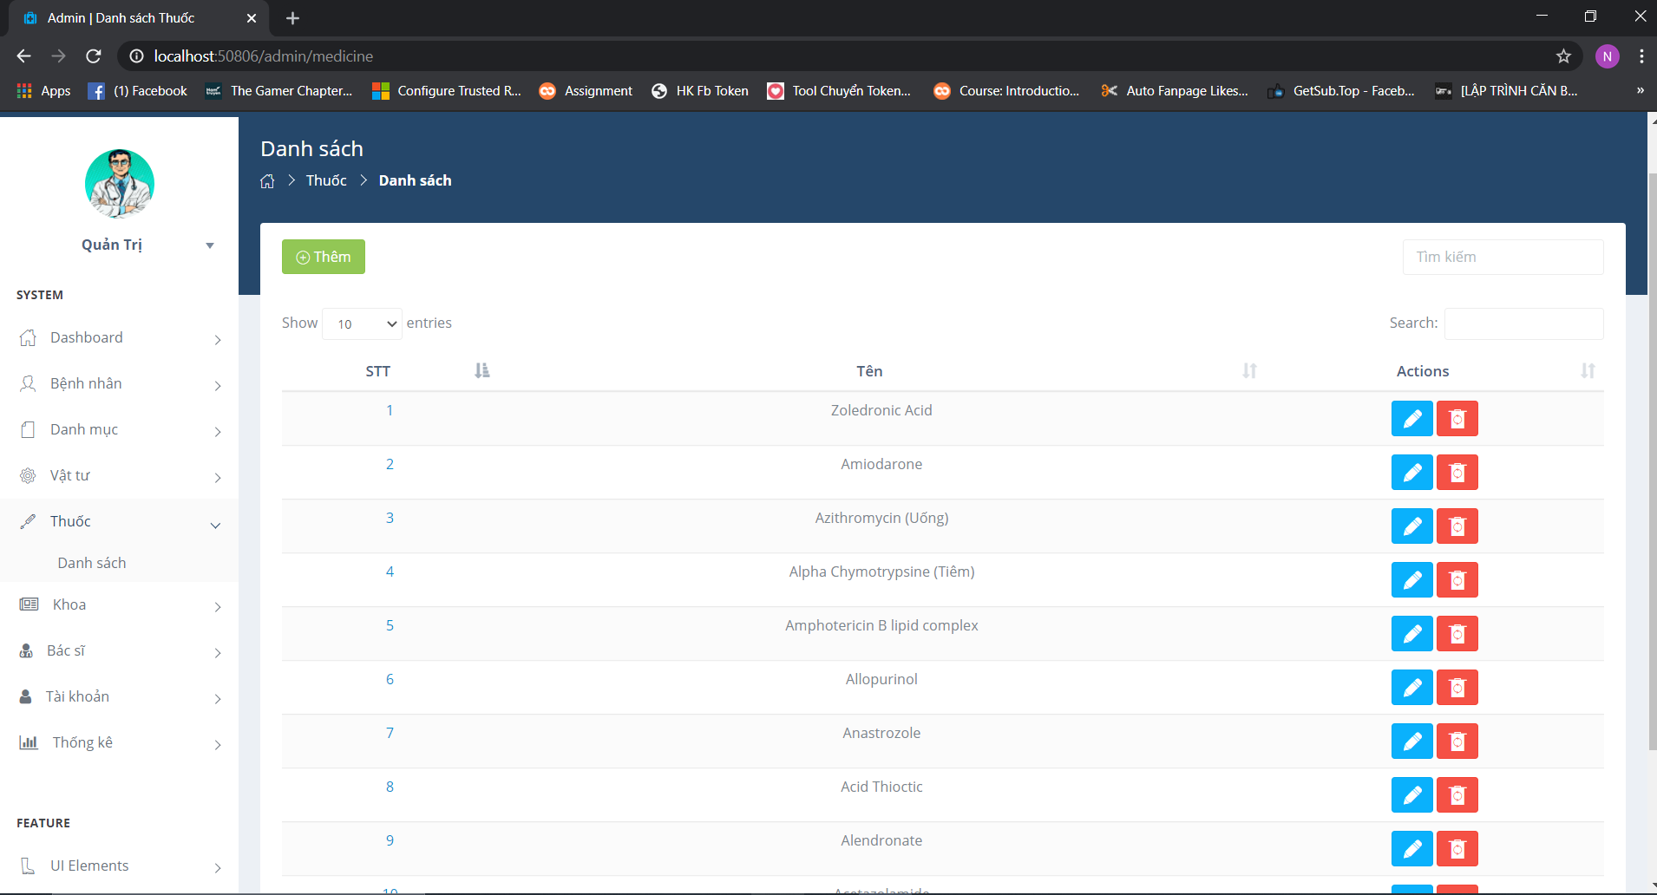

Figure : Page medical

Admin click Thuoc => Choose Danh sach. The page show all medical in hopital.

Admin can add, update, delete medical.

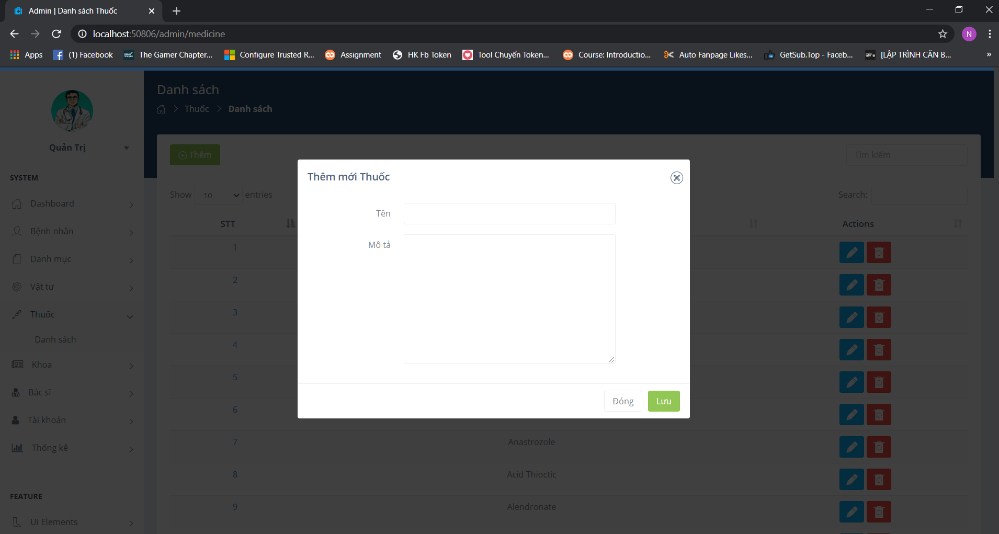

Figure : Function add medical

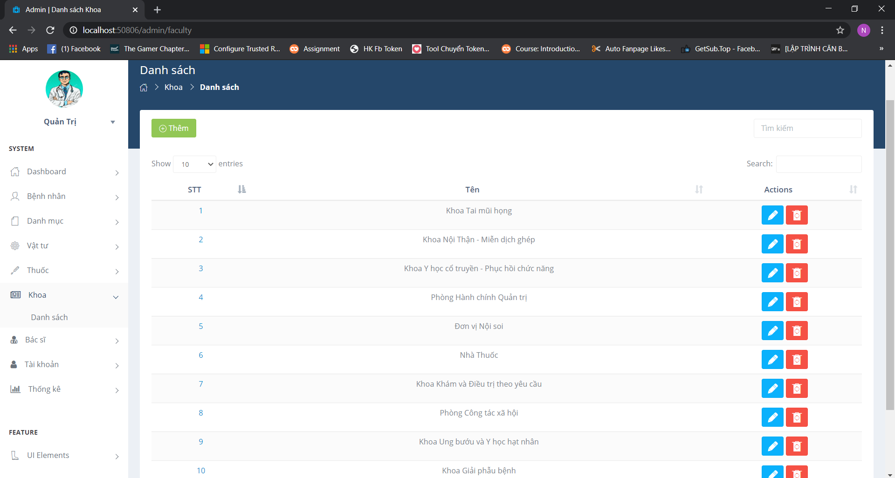

Figure : Page faculty

Admin click Khoa=> Choose Danh sach. The page show list of faculty.

Admin can add, update, delete faculty.

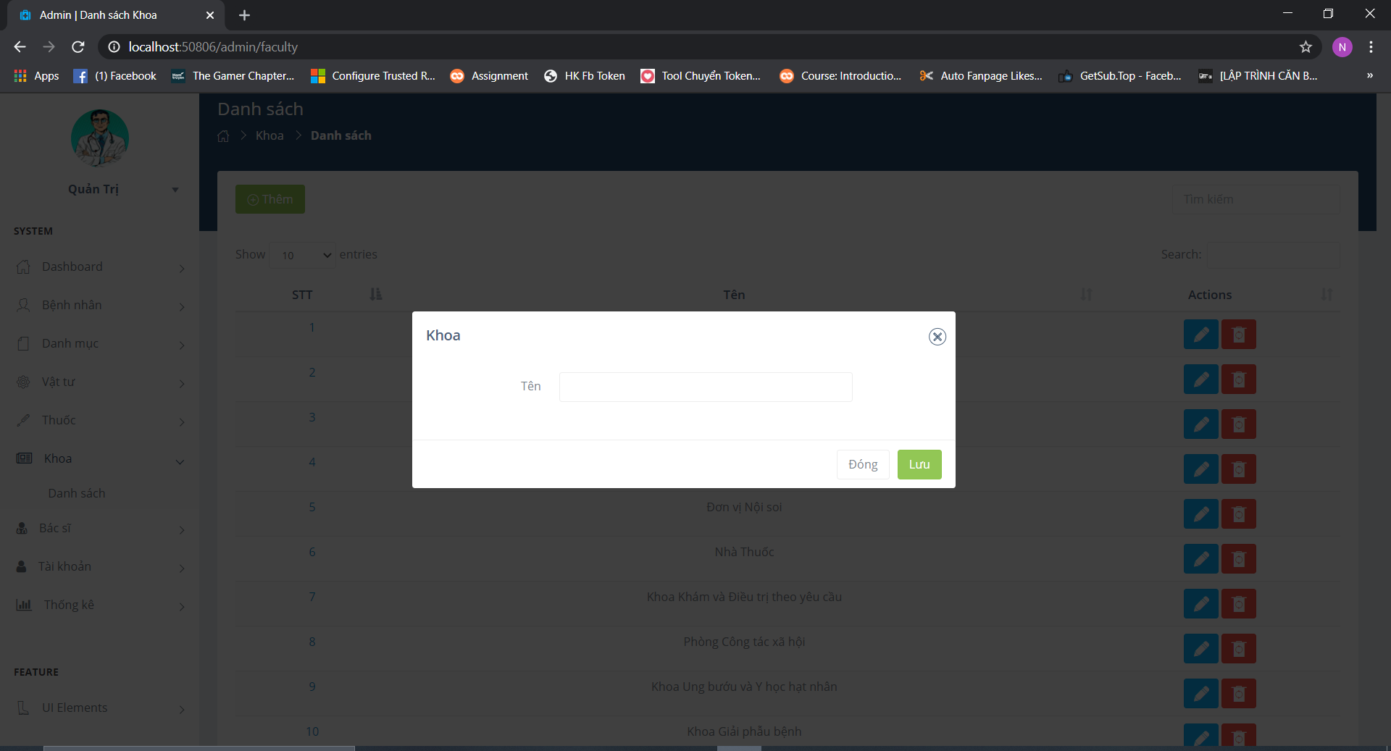

Figure : Function add faculty

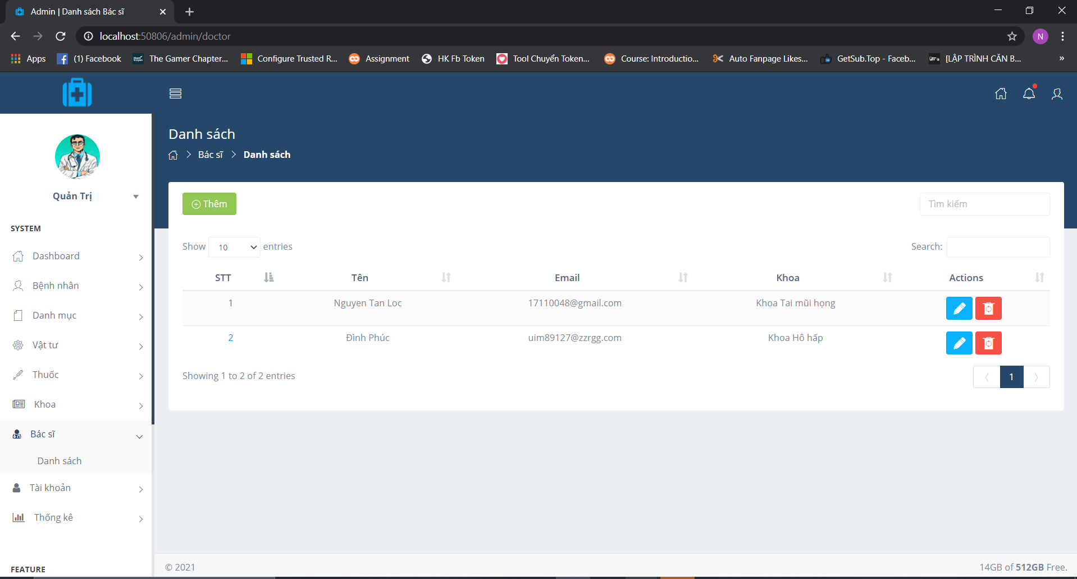

Figure : Page doctor information

Admin click Bac si => Choose Danh sach. The page doctor will display.

Admin can add, update, delete doctor

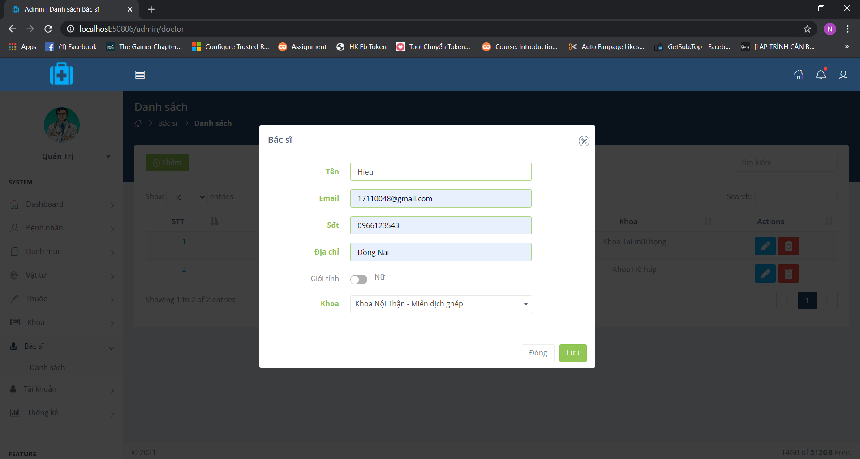

Figure : Function add doctor

Admin click Them and input information doctor

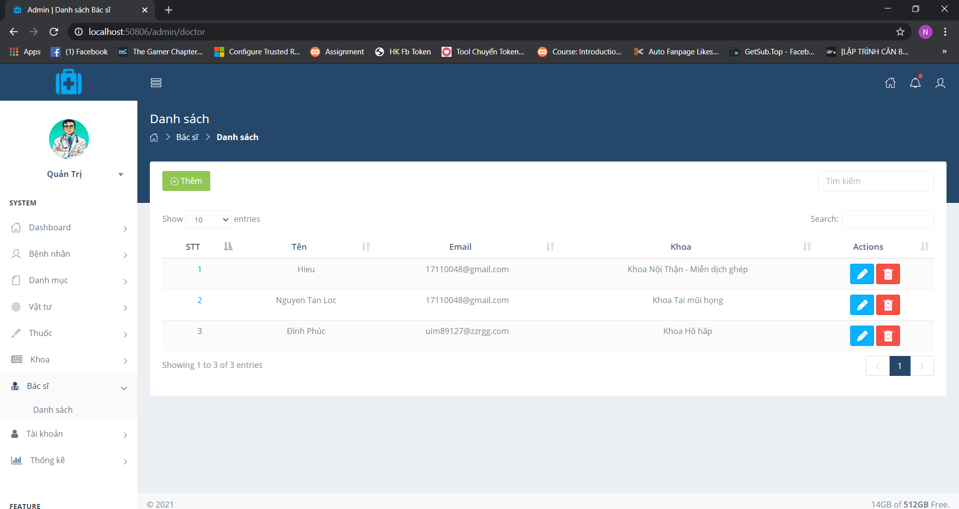

Figure : Save succsessful

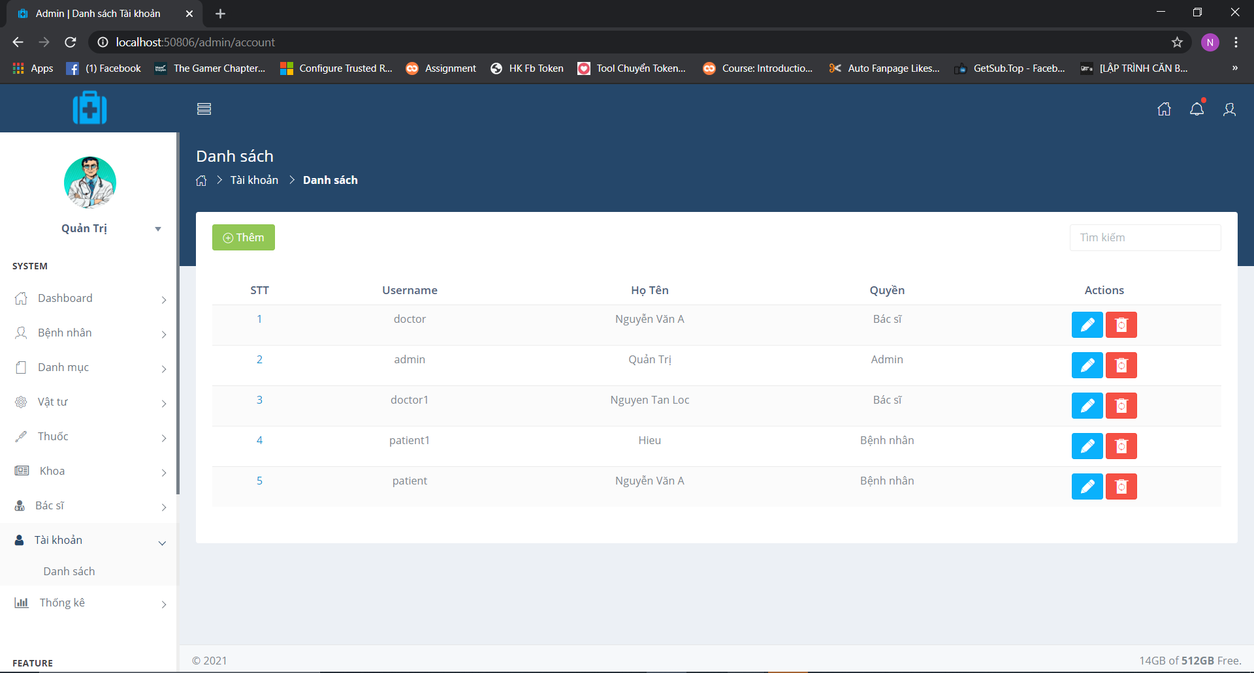

Figure : Page account

Admin click Tai Khoan => Choose Danh sach. The page account will display.

Admin can add, update, delete account of doctor and patient.

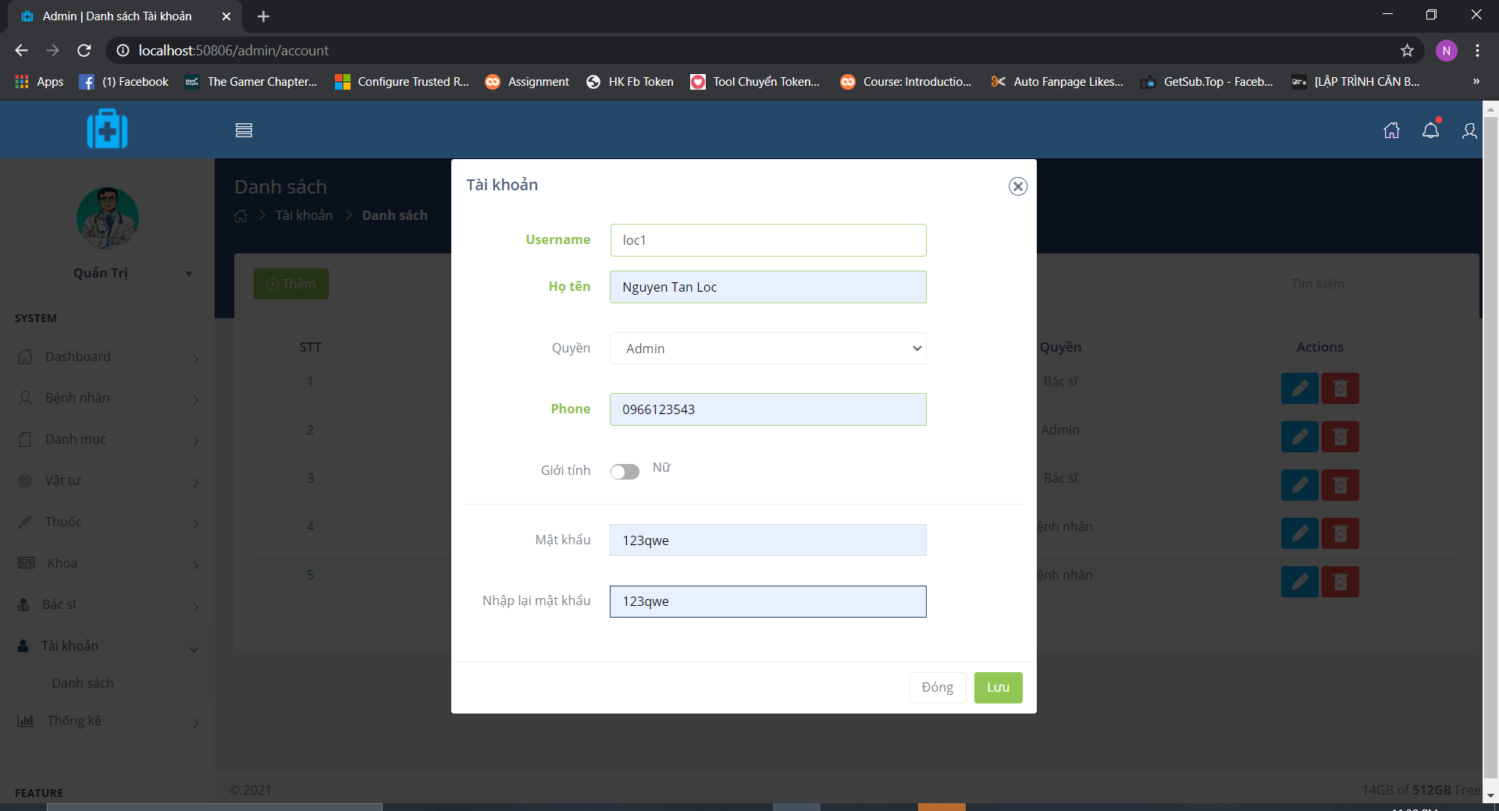

Figure : Function add new account

Function add new account have

Admin click Them button and input information.

Account have 3 role: Bac si, Admin, Benh Nhan.

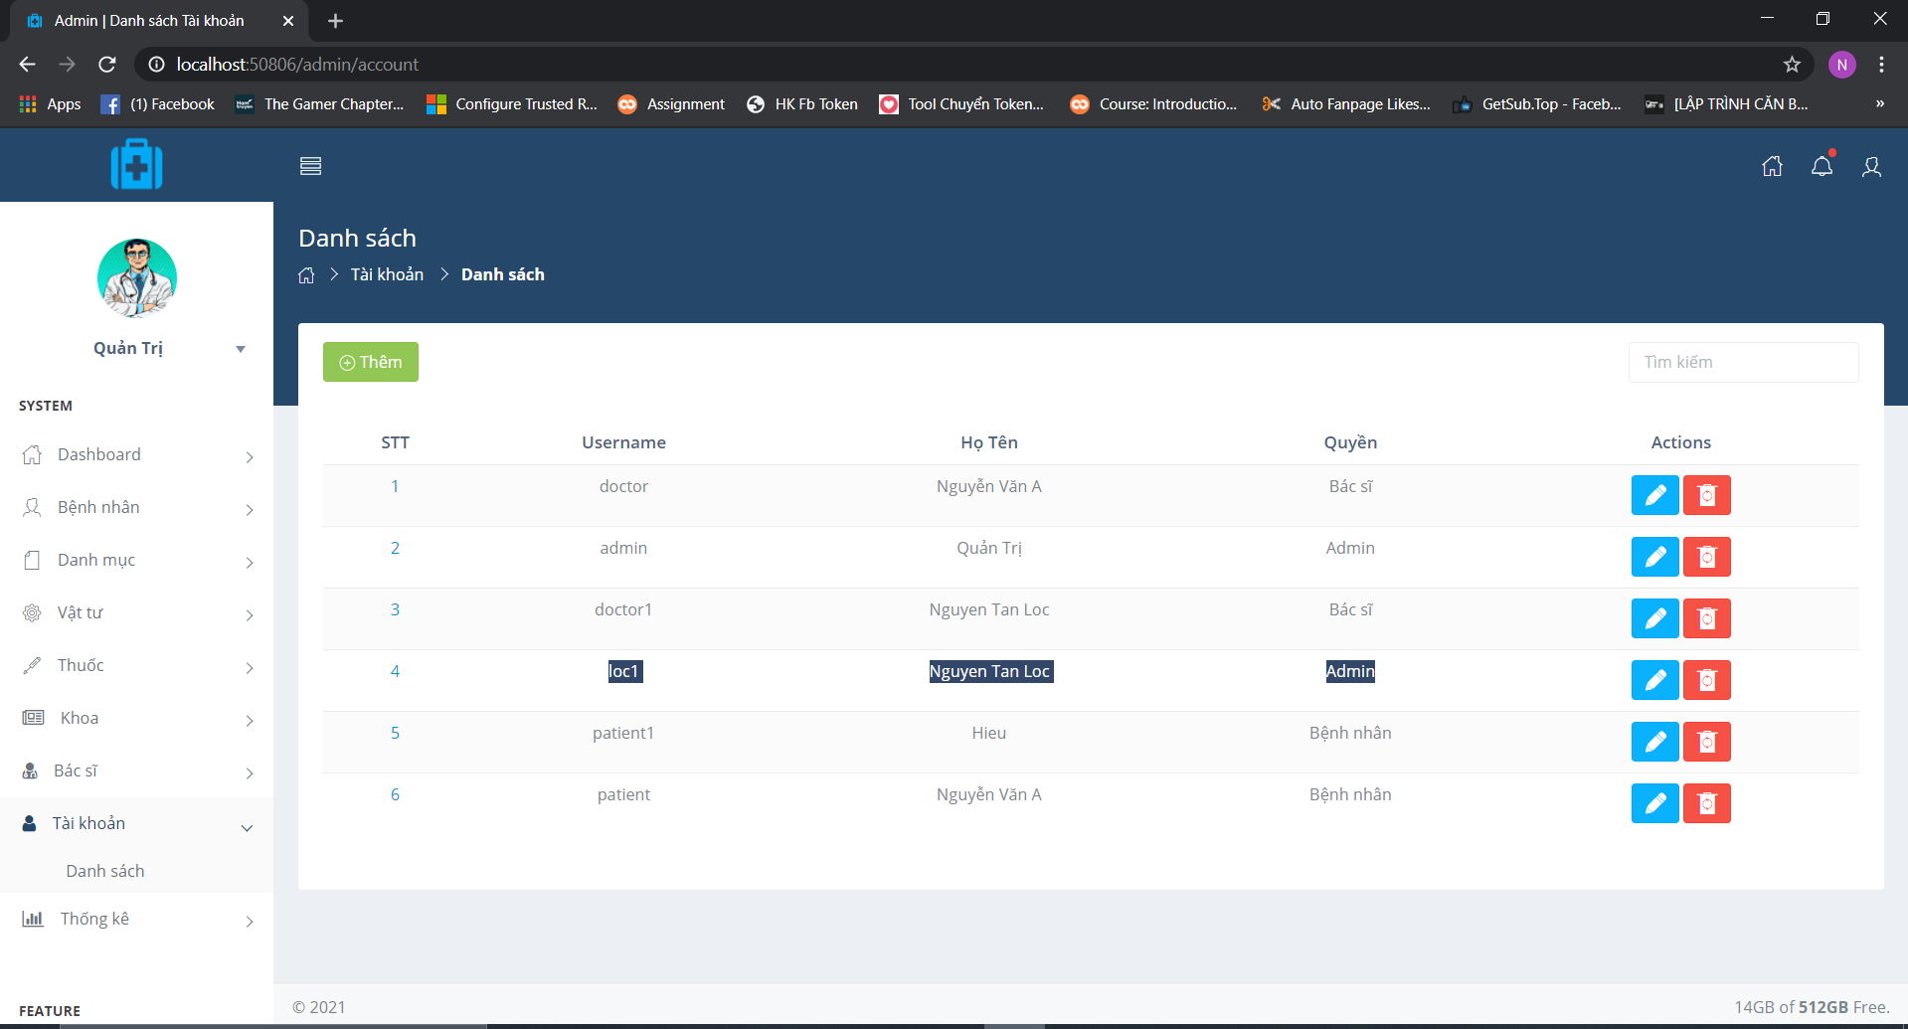

Figure : Add successful

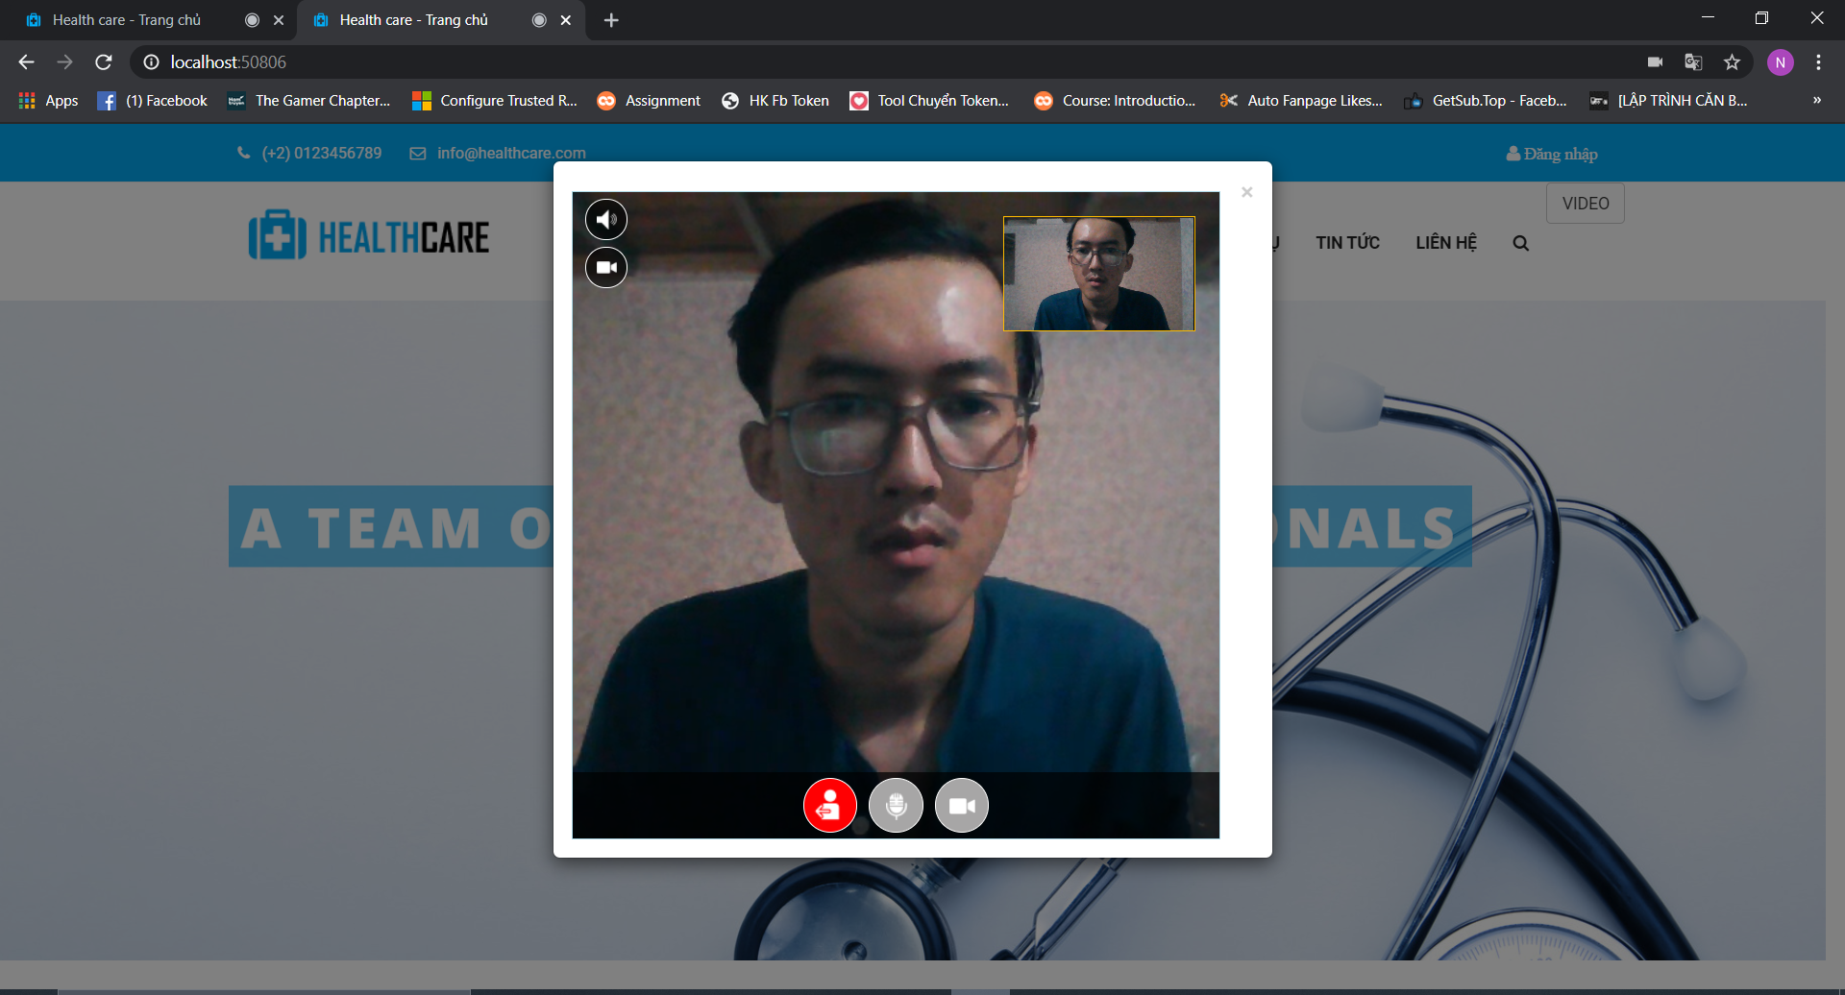

Figure : Embeded Video Call

Embeded video call use Vonage of OpentTok

# Chapter 5: Conclusion

## 5.1 Conclusion

During the project, the students achieved the following results:

- Practice surveys and learn to analyze the design and build of a system

- Analyzing the system's operations through decomposition charts, data flow charts.

- Analyzing object-oriented system design in UML unified modeling language.

- Designing an employee profile management module to prepare new employees to minimize paper work, save time

- The interface is easy to see, easy to use and can be widely applied in practice.

- Website may be added, enhanced with other functions.

Besides, because my capacity is still limited and the time for reporting is not allowed, there are many functions that I have not yet implemented:

- Decentralize functions for the administrator.

- Develop an organizational chart of companies and businesses Process of human resource operations: take leave, raise salary, change position ...

- Save the required draft I hope to receive comments from teachers / teachers to make my program more and more per

# Reference

1. Documentation about ASP.NET: https://www.howkteam.vn/course/lap-trinh-web 1ite-elephant-aspnet-mvc-co-ban-15

2. Knowledge about Html, Css, jquery: <https://www.w3schools.com/>

3. Video learning about ASP.NET: <https://www.youtube.com/>

4. Other resources are searched from google.